**Introduction**  
* React Hooks is a relatively new feature in the history of React.  
* We’ll have a look at what exactly it is, how it changes the way you write React code.  
* React Hooks give you a nice way of building your components and of thinking about your components.

**What are “React Hooks”?**  
* React Hooks help us work with our components in a more efficient way.  
* You either have **Functional** or **Class** based components **in React**.  
* In Functional components you’ve got **props** and you **return some JSX** code. They are great for presentation, for presenting your content but you **can’t change internal state** there. So therefore each Functional component typically is focused on 1 or only a few purposes and simply there to **output** **something**.  
* If you wanted to react to a button, you would do that by getting a handler, a function pointer as a prop and then by executing that function through that prop, so that the parent component which at some point has to be a Class based component, is able to for example change some internal state upon that button press.  
* **Class** based components unlike Function components don’t just receive **props** but in addition they can also **manage** **state** and **state is that changeable thing which triggers a re-render when you change it**.  
* Therefore your business logic typically lives in Class based components because typicall when something changes, you want to re-render and Class based components are the only components that can have something that changes and causes re-render.  
=> Therefore you typically also use Class based components to orchestrate your components and overall you have Class based and Functional components work together.  
* Now we’ve all been at the point where we had a Functional components and all of a sudden we needed to manage some state in there, for example you have an input there and you want to store the input user entered, in your state and send it back into the input. It is classic **2-way binding**.   
* In such a case, you would have to convert your Functional component to a Class based one. But of course, this conversion is annoying, it’s a lot of redundant work in the end.  
* In addition to managing state, **Class based components** also were the only components that could have Lifecycle methods called **Lifecycle** **Hooks** which are not **to be confused with React Hooks**.  
* These **Lifecycle Hooks/Methods** also could be **hard to use**, it could be **annoying to add** **componentDidMount(), componentDidUpdate() and ensure that you run the right logic at the right point of time and maybe add the right IF checks to avoid unnecessary re-renders or infinite loops**.  
* And for these reasons - for example to get rid of the conversion, we have React Hooks.  
=> **React** **Hooks** essentially allow us to work with **Functional components only**.  
* You still can create Class based components but you don’t have to.  
* You can write Functional components everywhere and **Hooks replace class-only functionalities**.  
=> **They replace state management and Lifecycle Hooks**.  
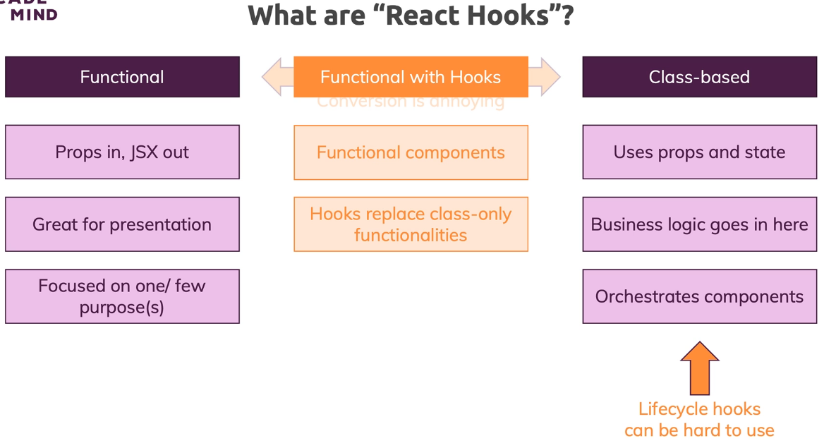  
* React Hooks themselves are in the end just JavaScript functions, not components, functions which **can only be used inside of Functional components or inside of other Hooks** because as it turns out, **you can also write your own Hooks**.  
* React Hooks are JavaScript functions named like this:  
**useName**  
=> For example: useState.  
* That’s the rule the React team came up with.  
* It’s not a technical JavaScript thing, it’s not a hard rule imposed on you by the languages.  
* Modern React projects got built in Linting - which are automatic code checks that will recognize such functions and yell at you if you’re using them incorrectly or if you’re using a Hook in a place where you’re not intended to use it - for example in a normal non-Hook JavaScript function.  
* The idea behind React Hooks is that you can expose certain - possibly Stateful - functionalities to Functional components like state but also like adding Lifecycle methods, a bit different than with Class based components but in the end, you make everything work that you could make work in Class based components.  
* **Hooks are highly reusable** and that’s a core idea behind them.  
* You can use the same Hook in multiple Functional components or other Hooks.  
* Each places that uses a Hook, uses it independent from the other places.  
* So you’re **not using Hooks to share date between components** but instead, **you can simply share functionality between components**.  
* You can add certain logic to multiple components but every component will then run that logic on its own.  
1) Add **state**  
2) Add **Lifecycle methods**  
3) You can **share logic across components and that logic can even be stateful**  
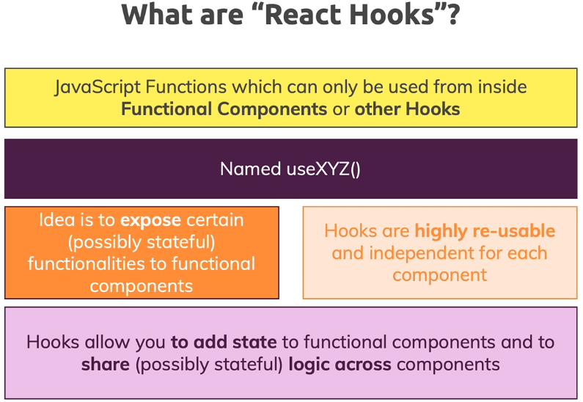  
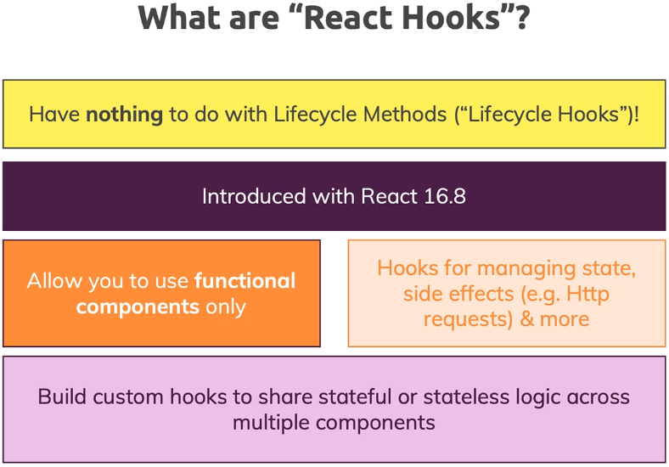  
* React Hooks are called Hooks because you hook a certain functionality into your Functional components or you Hook into certain React functionalities.  
* Lifecycle Hooks are just a synonym for Lifecycle methods and they are restricted to Class based components.   
* You can use React Hooks for managing state or **also for side effects**, for example for **sending HTTP Requests and then handling the response of these requests**.

**The Starting Project**  
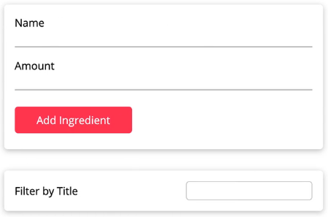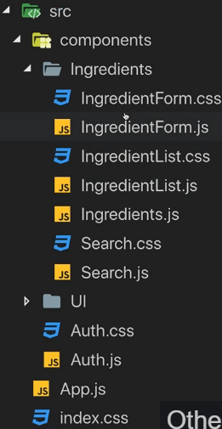  
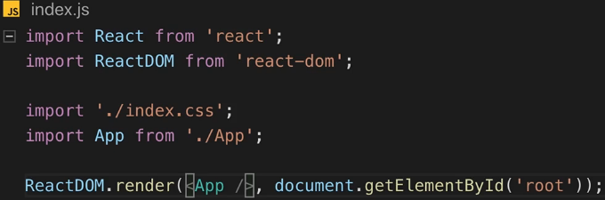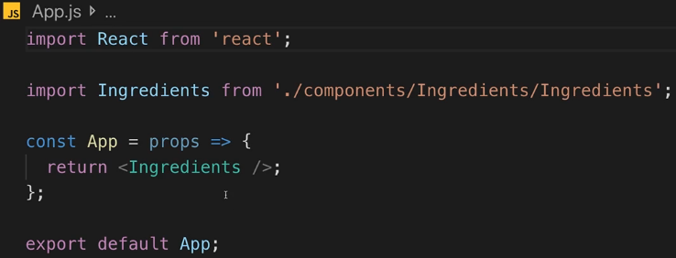

* It will do more later which is why I have this extra component, for now it just returns the Ingredients component.  
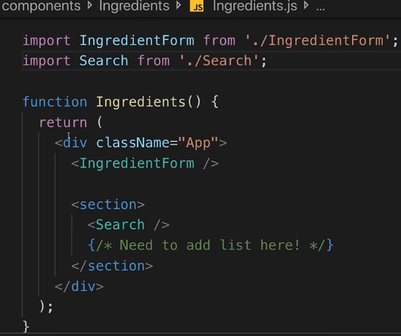  
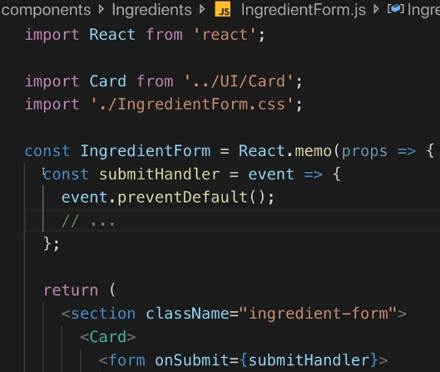  
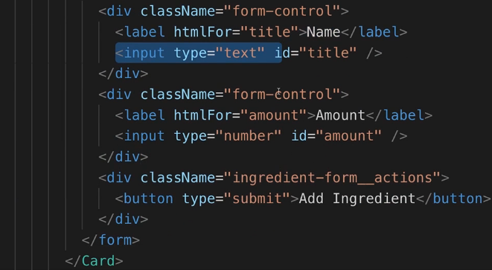  
* I’m using **React.memo()** here to wrap this component to **avoid unnecessary re-renders** so that this component **only re-renders when the props that it depends on changed**, and **not always when the parent component changed**.  
=> So not always when Ingredients changed, but only when Ingredients changed AND we’re passing new props to IngredientForm, which right now we’re never doing. So right now IngredientForm doesn’t re-render when Ingredients re-render. That’s just a tiny side note.  
* You learned about React.memo() in the Component Deep Dive module.  
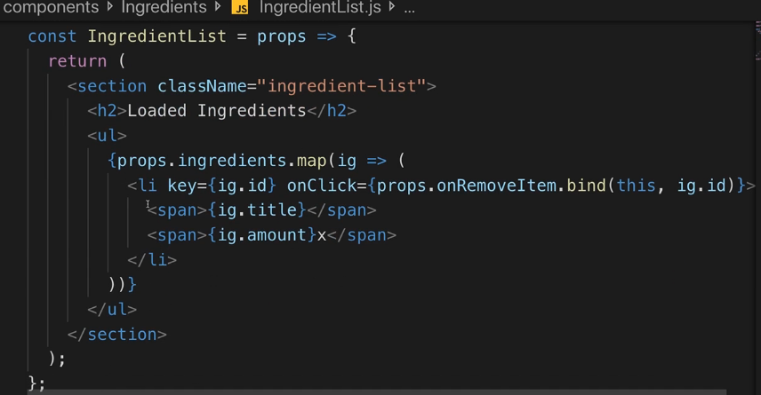  
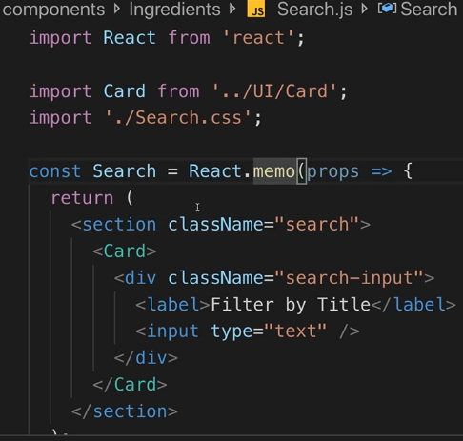  
* In the UI folder we have a couple of UI components.  
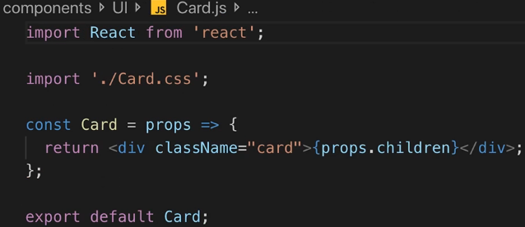  
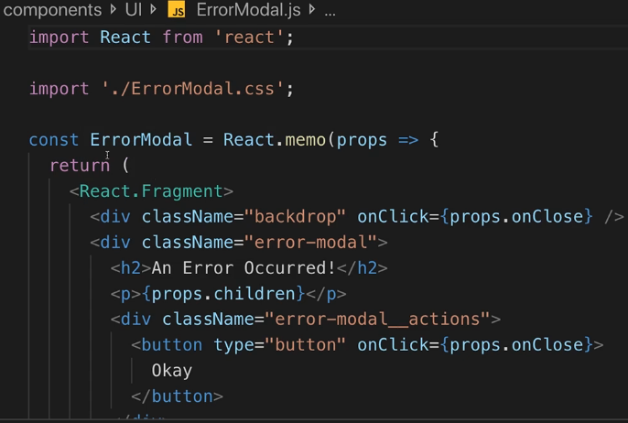

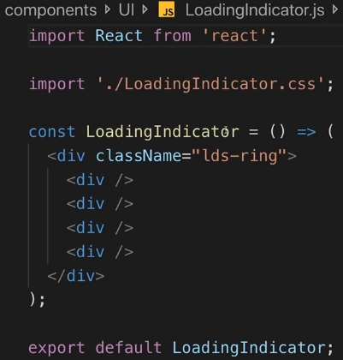  
* Right now this app doesn’t do anything, hitting the Add Ingredient button won’t do anything.  
* Now it’s up to us to wire this up.  
* **All these components here they’re all Functional components**.

**Getting Started with useState()**  
* **The most important Hook probably**.  
* It is worth mentioning that I also touched on hooks throughout this course.  
* So some of the hooks I’ll dive deeper into are Hooks I already mentioned throughout this course.  
* In IngredientForm we have a couple of inputs and one thing we typically would do here is that we bind the input that the user enters to some state property and we update that state on every keystroke and then send the value back into the input.  
* That’s that **2-way binding**.  
* I want to do the same here because ultimately it all starts in our app with us gathering the user input so that we can make this “Add Ingredient” button work.  
* Before React Hooks, you would need to transform this to a Class based component and use state and setState there.  
**useState() => This is probably the core Hook provided by React.**  
=> It allows us to manage state in Functional components.  
=> It works a bit differently than state in Class based components.  
  
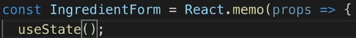  
* That alone doesn’t do much though, useState() **can be initialized with a default state** and that state **can be anything**, it can be an object, an array, a number, a string, a boolean, any value - unlike in Class based state where it always was an object.  
* Here I choose an object because I have 2 values I want to manage.  
* I set the amount to a string because it will be easier to manage because the values of input elements are always strings, even if it’s of input type number, it will always get a string.  
  
* useState() returns something:  
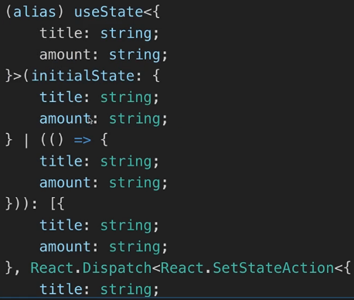  
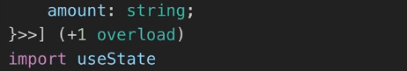  
* **The return value is an array - an array with 2 elements**.  
=> **useState() always returns an array with exactly 2 elements**.  
**1) element** => **current state snapshot**  
=> **Whenever your state updates, the component it’s in, will re-build**.  
=> React internally saves that you already configured a state with the help of useState() for this component and will not re-initialize it but instead useState() manages this state detached from your component so to say - independent from your component, so that the state survived re-renders of this component.  
=> Therefore useState() is the first value which is returned.  
=> It’s the current state snapshot for this re-render cycle of this component. This means that when you update the state, you’ll get the updated state.  
=> It’s either the initial state or - if you changed it - the updated state.  
* How do you change the state? That’s where the 2nd element in the array is helpful  
**2) element** => **a function that allows you to update your current state**.  
=> It’s a function which you can call with new data for your state to update that state.  
  
* Now we can connect it to our inputs. We’re going to use a similar approach as we saw with 2-way binding where we bind the value of this input to the current state snapshot - so that we pass the current state snapshot back into the input.  
  
  
* Of course we also want to **update the state** when we type into these inputs:  
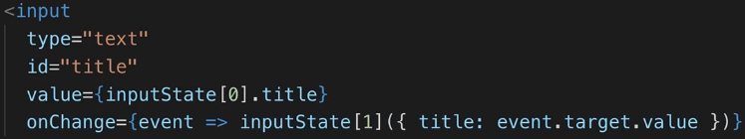  
* Now it works but we get a warning:  
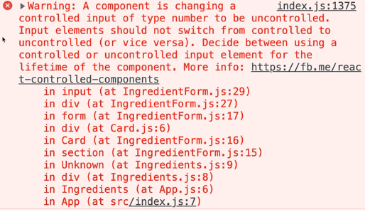

**More on useState() & State Updating**  
* The was we use state is correct.  
* **But the way we update the state is not correct**.  
* There’s 1 super important difference when you compare useState() and how you work with state in Functional components to how you worked with setState() and the state in Class based components.  
* In the regular state we had to use an object and there whenever you called setState(), whichever object you passed into setState(), was merged with your existing state, the old state would be kept.  
=> With **useState()**, the updating function (2nd element of our array) **updates the state by replacing the current state with whatever you pass**.  
* **It might sound like it should do that for us, but you’ll later learn why React doesn’t merge this for us anymore**. Now we have more flexibility regarding how we manage state.  
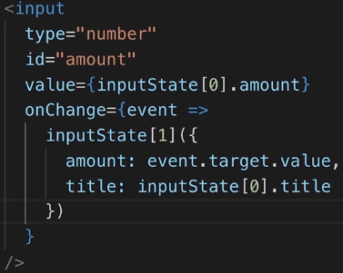  
* **Our code is not 100% correct yet**.  
=> **The way React updates the state, we are not having 100% guarantee that our current state snapshot actually is the latest state we committed**.  
=> Due to the way React re-renders components upon state updates and so on, you could theoretically have a case where there’s lot going on on your page - let’s say a lot of animations or a lot of stuff that React decides to defer a state update until there’s less work going on and therefore a user might be typing here into the input before the latest amount input because the user also typed into the amount input field a second ago before that state change has been rendered to the screen.  
* It’s very unlikely for this to happen and in our simple application it will never happen.  
* But in more complex apps you could have a case where you’re changing some state and your latest state change hasn’t been committed yet, hasn’t been rendered to the screen yet.  
=> Hence if you have a new state change that also depends on your latest state snapshot, then you don’t have a guarantee that this state snapshot has already been committed/created and therefore accessing our latest state value like this is not the ideal way.  
* Instead, this updating function has an alternative form which you can use.  
=> Instead of just passing a value to that update function, you can also pass a function to that function - an anonymous function for example.  
=> If you pass a function there - which of course has to return your new state value in the end - there we get an argument passed in automatically by React.  
=> **Previous state**.  
=> This will tell React that we want to get the latest state that we set, even if it hasn’t been fully committed yet for this render cycle.  
* The difference is that we’re now not using the latest state which has been fully committed and which is used in this render cycle of this component but we’re using the latest state we set with an updating function, no matter if React already recreated the function or not, based on that last update.  
=> Now we have the guarantee that we get the latest state at all times.

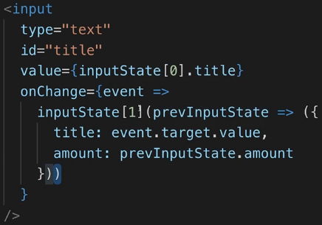  
* Now if we start typing, we get an error:  
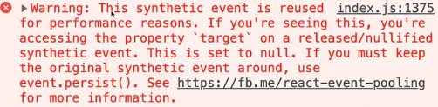  
=> **It tells you that you reused an event essentially**.  
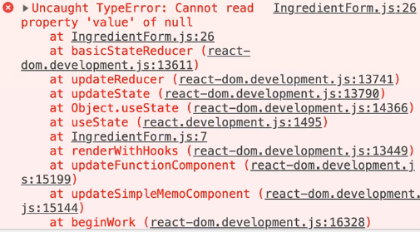  
=> The problem here is that when we’re passing a function to this function, then we’re having this anonymous function here an that’s a **Closure**.  
=> That’s simple a function that closes over surrounding values and in this case it closes over our event here. The event is fed into this onChange anonymous function and in that function we’re calling the set state function so we’re calling a function but then I’m defining yet another nested function.  
=> The problem is that if in the inner function I use something from the outer function, then this event will be locked in for the first keystroke essentially - which means that for subsequent keystrokes we don’t use the new keystroke event but the previous one which of course is then reused and which causes this error.  
* Normally this wouldn’t be a problem of course because this inner function is a closure and therefore it closes over the event object which means it saves this event object for its execution so that when this inner state updating function runs - which happens asynchronously - we’re guaranteed to use the event that was triggered for that keystrokes - or it was created for a keystroke.  
=> The problem with events (and that’s not really exclusive to events in React) - is that React events are not the native DOM events but special synthetic events created by React which basically replicate the native DOM events you would normally get but React adds a special factor to that - it pulls these event objects, which simply means it reuses event objects. So instead of creating a new event object for every keystroke, it instead reuses the previous object.  
=> The consequence of this is that for the second keystroke since we have a Closure and we locked in the event for the first keystroke, for the second keystroke we still reuse that same object we had for the first keystroke and that’s the problem - we’re reusing the wrong even object because of the way React handles event objects.

=> **The solution is that outside of this set state function, we create a constant where we store the event.target.value - now this will be recreated whenever we’re typing**.  
=> Now this nested function can use new title and this will therefore now close over this new extracted title for every keystroke, instead of using that same event all the time.  
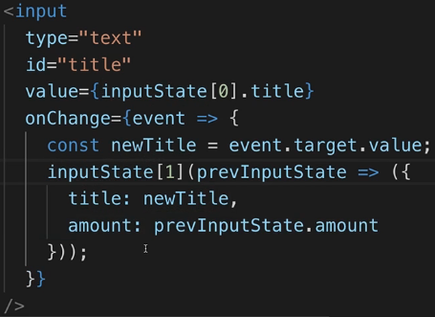  
* So we did this simply because we’re using a Closure and **we want to make sure that we’re generating a new amount for every keystroke**, and then this will automatically be considered by this inner function instead of reusing that same event object all the time.

**Array Destructuring**  
* **Let’s work on the overall syntax we’re using here**.  
* Thus far we’re storing this array we’re getting back in the inputState variable and we can absolute do that, but it means that we have to use inputState[0] if we want to get the values and inputState[1] if we want to get the function to update the values.  
=> It’s a bit of a hard to understand syntax - for example that this is a function is not immediatelly obvious.  
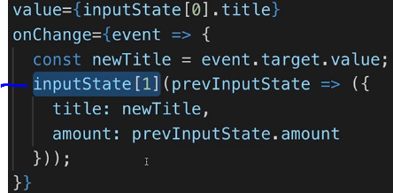  
=> We can use a modern JavaScript syntax to make that easier to understand.  
**Array Destructuring** => allows you to pull elements out of an array and store them in separate variables.  
  
* That’s way easier to read and use now.  
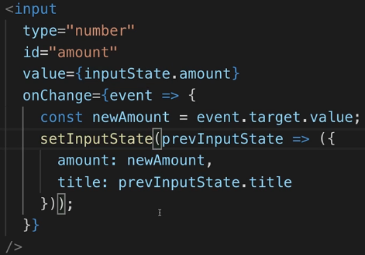  
* **That’s the syntax you’ll see in the official docs**.

**Multiple States**  
* **One thing I’m not liking too much is how complex it is for us to update the state**.  
* Imagine we had a lot more data - we would have to write a lot of code just to always save all the old state when you update something new.  
* So while you can of course manage state that is an object and while it often might make sense, you should also be aware that there is a huge important difference when you compare the state added by useState() to the state used in Class based components.  
=> In Class based components, state had to be an object and React merged it for you automatically.  
=> With useState(), state doesn’t have to be an object and React doesn’t merge it for you.  
=> But **what you can do is register multiple states**.  
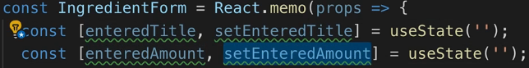  
=> So now I have 2 states which are both **managed independently by React for this component which are stored in different variables and which you can set with different functions**.  
=> So now I don’t have to manually merge anything because there are managed independently so if I update one, the other one will be kept around because **these states survive re-render cycles, so they survive updates of other states**. We don’t have to merge manually because it’s not an object anymore but instead we have 2 separate strings which are managing a state.  
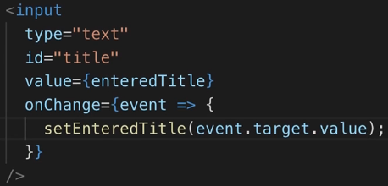  
* **We don’t have that Closure problem anymore** because there’s no inner Closure in this function anymore.  
* **This is my recommended way of doing this**.  
=> **Split your state into multiple states, that’s how useState() is intended to be used and only use objects or arrays as values for your state if you really have data that changes together or where you need to change multiple things together. Otherwise manage your state independently**.

**Rules of Hooks**  
* The idea behind useState() is that we can manage state in a Function component by calling useState() with some initial state which we can set up. **You don’t have to pass an initial state** - if you want to have **null or undefined as initial state, you can simply pass no argument** at all to useState().  
* **This creates a state which is managed by React behind the scenes and which survives re-render cycles**.  
* You can back an array with exactly 2 elements.  
=> **A pointer at your state**  
=> **A state update function**  
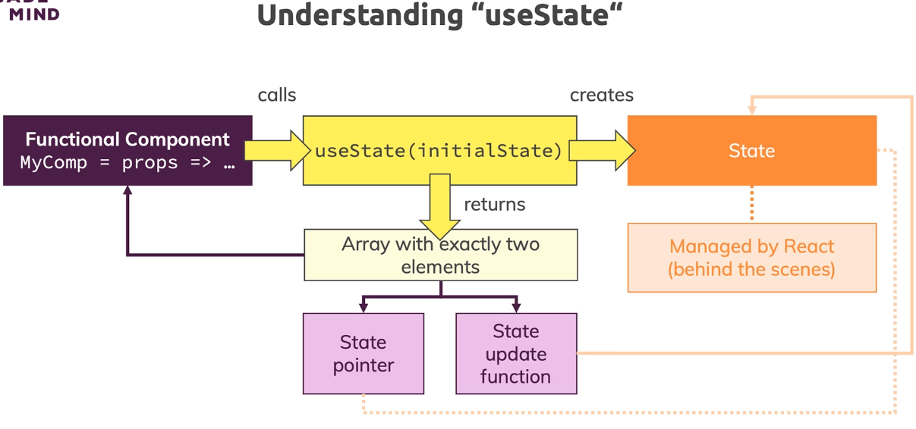

* **There are 2 important rules when you work with any Hooks**.  
**1) You must only use the Hooks in Functional components or inside of other Custom Hooks**.  
**2)** **You always have to use the Hooks on the root level in your component**.  
=> **It means you can’t use a Hook in some nested function or an IF statement**.  
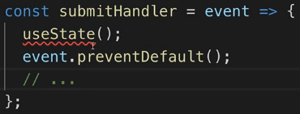 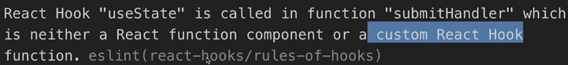

* **You can define functions inside the Functional component**:  


**Passing State Data Across Components**  
* In the submitHandler I want to submit my data.  
* In Ingredients.js I want to later output the list of ingredients so it is a component that has access to both our input and our output later. So I want to manage the ingredients in there.  
* Here I use an array because ingredients will be a list of ingredients and we will always update that list as a whole when we add/delete an ingredient.  
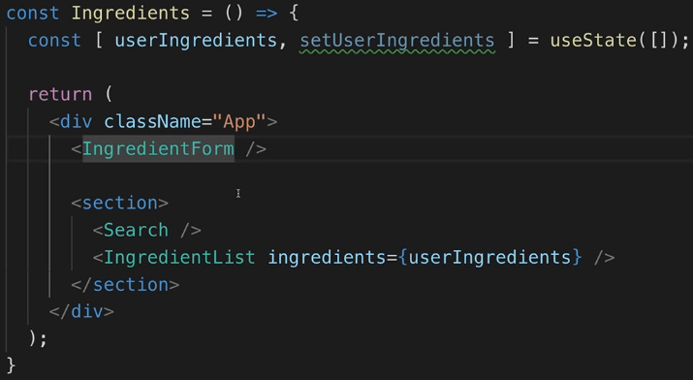  
* We also added the IngredientList.  
* In Ingredients.js:  
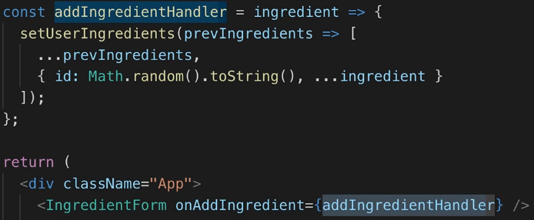  
* We need to update the existing list of ingredients and add a new one, that means **we depend on the current state** and therefore it’s best if we **use the functional form** where we’re **guaranteed to get the latest state**.  
* The ingredient will have a title and an amount but probably not an ID because the ID should be somehow auto generated.

* In IngredientForm.js:  
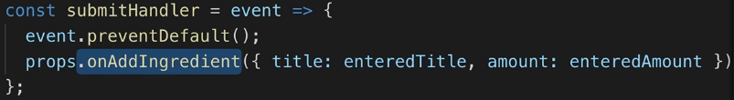

**Assignment 6: Time to Practice: Hooks Basics**  
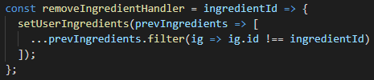

**Sending Http Requests**  
* I’m going to use **Firebase as a dummy Back End - Realtime Database and start in test mode**.  
* I just want to have a server we can talk to which automatically has a database attached to it so that the data also gets stored there.  
* To send requests we can use **AXIOS** or the **FETCH** **API** which is built right into JavaScript.  
* **To mix things up, I’m going ot use the FETCH API**. (we used Axios previously)  
**fetch() => it’s a browser function so to say, it’s built into modern browsers**  
* Firebase requires .json at the end of the url.  
=> **By default, it will send a GET request**. **Firebase wants a POST request though**.  
=> **Pass 2nd argument to fetch() which is an object which allows us to configure this request**.  
**method: ‘POST’  
body: x => what you want to send, it has to be json data  
headers: { ‘Content-Type’: ‘application/json’} => that’s what Firebase expects (Axios would do it for us, FETCH doesn’t, just as it doesn’t convert the data for us)  
JSON.stringify() => takes an object or an array and converts it into valid JSON format**  
* We don’t need to pass the ID because Firebase will do that automatically for us.  
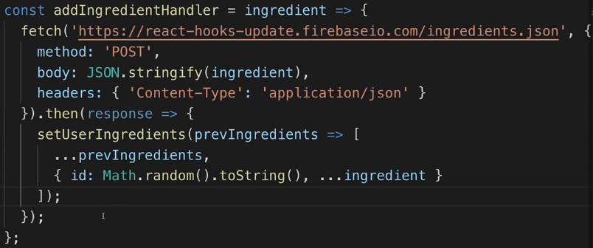  
=> This will now **return a promise** which will eventually resolve once this request successfully was sent once it fails.  
**then()** => Let’s say we want to update our data locally when this promise is done.  
* With promises, the thing is that the function you’re passing to then() will not execute immediatelly but only when this request is done.  
* **You could also use** **async await**.  
**json()** => extracts the body and converts it from json to normal JavaScript code, however, this also **returns a promise** so we’ll actually return response and move the local updating to another then().  
* **Firebase => response.name contains that automatically generated ID**.

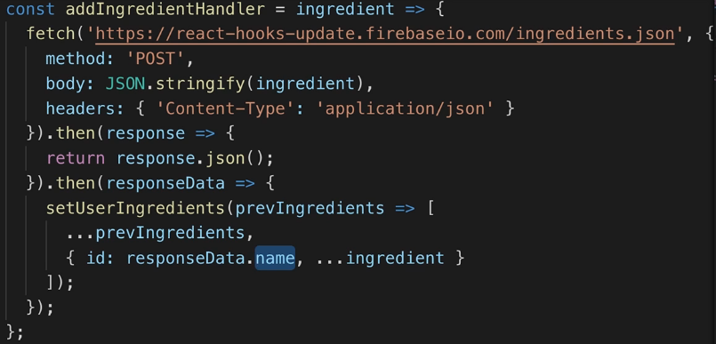  
* Now if we reload, we lose our data, so our next goal is to fetch the data whenever we reload - so whenever our app starts or whenever Ingredients.js gets rendered so to say.  
* For that we normally would’ve used Lifecycle methods - componentDidMount().

**useEffect() & Loading Data**  
**useEffect()** => It’s there for you to **manage side effects**.  
=> By default gets **executed right AFTER every component render cycle** - so after this component has been rendered the first time, the function that you pass to useEffect() will get executed. So **every time this component gets re-rendered**. These are 2 important pieces: **AFTER EVERY** **(re)render**.  
=> you have to use it at the root level of the Functional component again.  
* HTTP requests are a typical side effect.  
* Side effect means that you have some logic that runs that does affect your application for example we are fetching some data, but it’s not getting finishined in this current render cycle or maybe it affects something which is outside of the scope of your JSX code down there, mayabe you’re setting the document title, anything like that.  
* **What if we call the fetch at the root level?**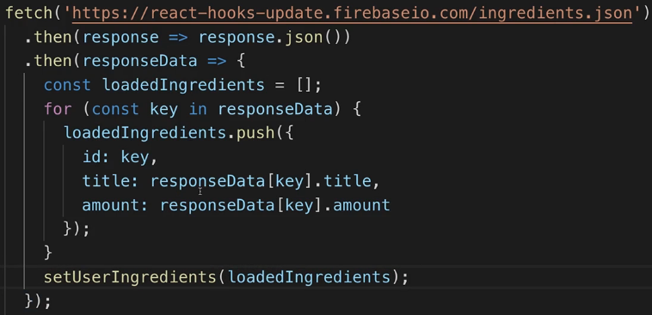  
* key will be the unique ID.  
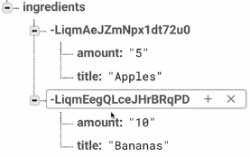  
=> **This approach has 1 huge issue - you end up with an infinite loop**.  
=> If you fetch data right here in the render function, then whenever Ingredients.js renders, you’re sending an HTTP request and when you then as a result after the HTTP request update the state, what happens if you update your state? => Component renders again, so Ingredients.js renders again.

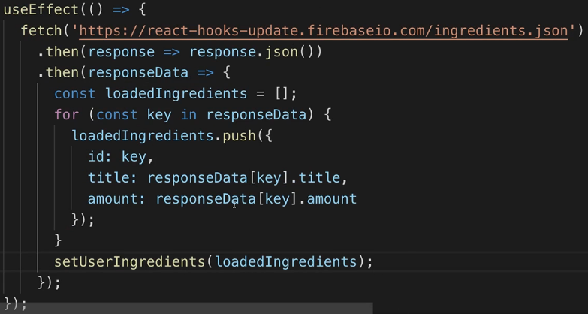  
=> Now we’re executing this **AFTER EVERY** render cycle but still by default for every render cycle and hence we **still have an infinite loop**.  
  
=> **useEffect() can take 2 arguments** - the 1st argument is this function which it executes, the 2nd argument is **an array with the dependencies of your function** and **only when such a dependency changes, only then the function will re-run**.  
* Here we have no external dependencies and with external dependencies I mean variables or data you’re using which you define in your component outside of the useEffect() function. We have the **setUserIngredients** function stored in a variable coming from outiside, but that’s **a special function since it’s generated by useState(), React automatically creates it such that this function never really changes and doesn’t have to be considered as a dependency**.  
* Therefore this useEffect() function has **no external dependencies** and so we can **add an empty array** => **ONLY ONCE**, ommitting it causes it to run for every render cycle which causes the infinite loop.  


  
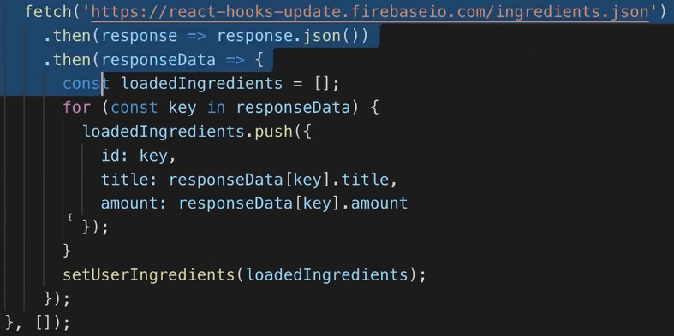

**Understanding useEffect() Dependencies**  
* **You can have as many useEffect() in your component as you want, just like with useState().**  
* You should configure the array you pass as the 2nd argument in an honest way though - you should really specify your dependencies, if you have a dependency - for example here if you output ingredients, than you should specify it as your dependency:  
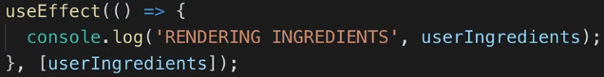  
=> This function here will now **only run when userIngredients change**.  
=> Right now in this app it’s the same as running it on every render cycle but if we had something else that could be executed which also re-renders the Ingredients, let’s say we had some other value we’re managing in there which we can change with a set state call in the end, then this function would only execute if userIngredients changed and not if that other value changed.  
* You can ommit the 2nd argument if you know you want to run it for every re-render cycle but if you know you only want to run this if it changed, you should specify it.

**More on useEffect()**  
* Our Search.js component should be responsible for showing only what matches our input:  
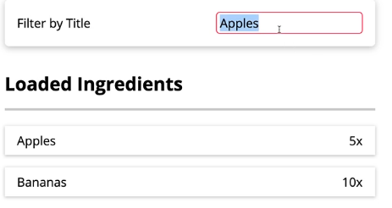  
  
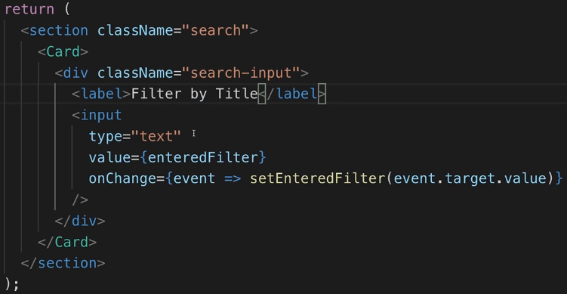  
* Now the idea is that whenever the user types something to here, we try to fetch filtered data from Firebase.  
* **You could register a function for onChange which basically sends an HTTP request on every keystroke, that would work**.  
* Here, however, I’m updating the saved value on every keystroke and instead what we can do is we can use **useEffect() and pass in a function that should do that HTTP request and we specify the enteredFilter as a dependency**. That means the function will execute whenever enteredFilter changes.  
* It’s the same result but in my opinion it’s a bit more elegant because we’re really embracing the idea of Hooks here and we’re splitting our logic.

* In Search.js:  
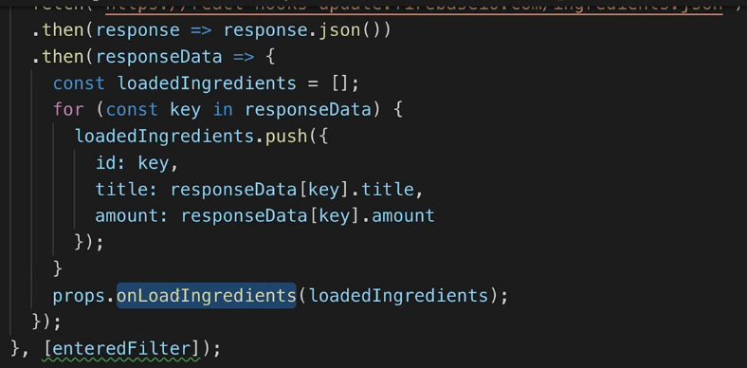  
* In Ingredients.js:  
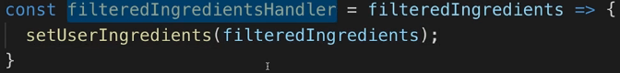  
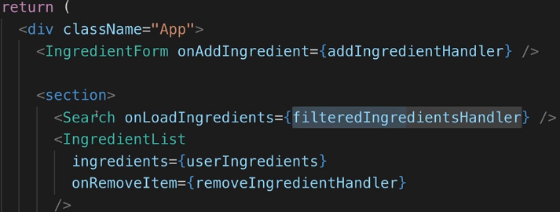  
* We rely on the props as the dependency - you might say we’re only pointing to a function and that function shouldn’t change, so that shouldn’t re-run if props change - but you should never cheat regarding your dependencies. It’s a good practice to always be clear about all dependencies you have. In here, props is a dependency.  
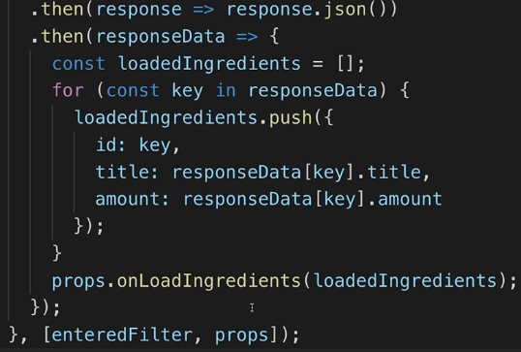  
* But still we’ll have a problem with that - **now this re-runs whenever props change** and that basically is the case whenever anything passed to this component changes or whenever anything in the parent component changes. **That’s also not what we want**.  
  
=> We can use **Object Destructuring**.

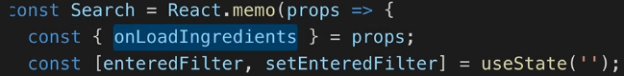

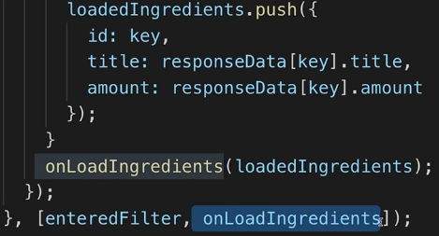  
* Now it’s going to re-run only if the enteredFilter or onLoadIngredients function change.  
* We need to make a change in Firebase to be able to filter it:  
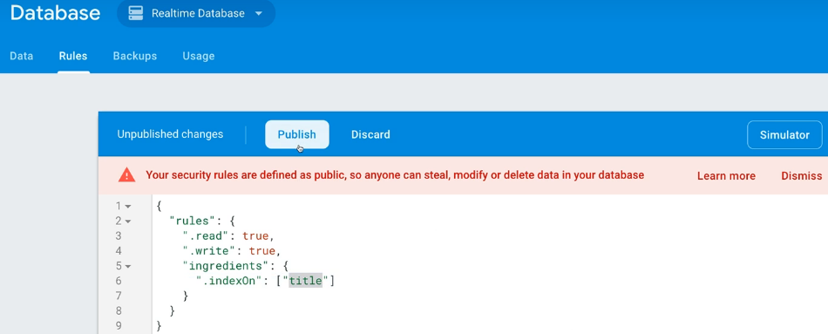  
* Now let’s just modify the fetch to return the filtered ingredients.  
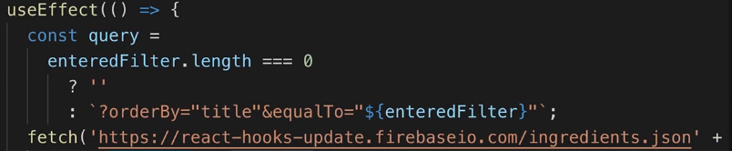  
* **Now we have an infinite loop again**.

**What’s useCallback?**  
* The infinite loop is caused by the onLoadIngredients() dependency - this effect will run whenever enteredFilter or onLoadIngredients() changed - that will be the case for the 1st time Search is rendered so it will definitely fetch our data whenever Search is rendered. But there after we re-run only if enteredFilter or onLoadIngredients change - which we’re extracting from our props, that is the case the parent component is re-rendered, the parent component is re-rendered because in the end the first time we load the data we’re calling onLoadIngredients which calls this filteredIngredientsHandle function and in there we’re calling setUserIngredients which changes the state which re-renders this component which means that here we’re also creating a new filterIngredientsHandle function because this entire component re-runs and at the end this is just a JavaScript function - so even these functions you have in there they still re-run, they’re still created again because in the end it’s just a variable which now receives a new value, of course it has the same logic as before but technically it’s a new function object in JavaScript so it’s a new object we pass to onLoadIngredients and therefore it will re-execute the useEffect in Search.js.  
=> **Because we re-rendered the parent, all these functions are created new and so we run the useEffect().**   
  
=> To prevent this from happening, we can use another Hook.  
**useCallback()** => **allows you to wrap one of your functions with it and you pass a 2nd argument which is an array with the dependencies of the function you passed in the 1st argument**.  
* In our case it’s the special function and has no dependencies so we can pass an empty array [], but of course you can pass setUserIngredients - that’s guaranteed by React that it never changes.  
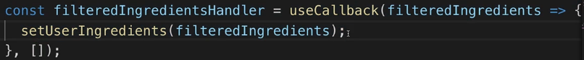  
=> React caches your function for you so that it survived re-render cycles and therefore when Ingredients.js re-renders, this specific function is not re-created, so it will not change and so what we pass to the Search.js will be the same function.   
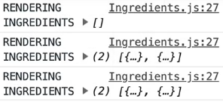  
=> **We still see 1 extra re-render cycle to which I’ll come back in a second**.  
* **We’re sending the request with every keystroke which might not be ideal**.  
* **We have an extra re-render cycle initially**.  
* So we should fix that.  
=> Let’s make sure we don’t have the extra render cycle initially.  
* It’s actually coming from a redundant HTTP request we’re sending.  
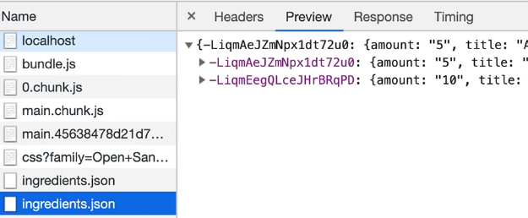  
=> Why do we have 2 requests being sent there?  
=> **Because we send 1 in Search.js - executes when Search.js gets first rendered**.  
=> **And we’re also fetching data in the Ingredients.js component when it gets first rendered**.  
* **Since we’re already guaranteed to fetch ingredients because we’re doing that in Search.js, we of course don’t need that extra useEffect() in the Ingredients.js component, so we can remove it**.

**Working with Refs & useRef()**  
* **We’re sending the request with every keystroke**.  
=> We might not want to do that because we’re spamming our server with requests, so it would probably be better if we set some timer and if the timer expired, we check if the current input is the same as at the beginning of the timer. **setTimeout()**  
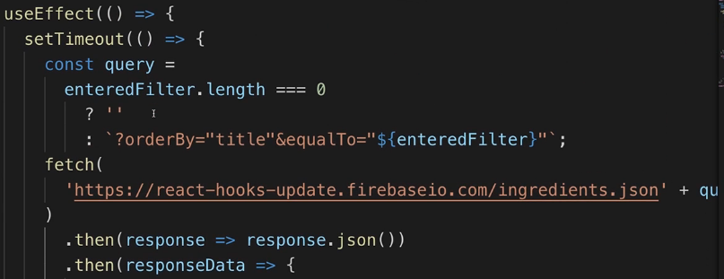  
=> Only if the user stopped/paused typing for 500 milliseconds, we want to send the request.  
* Right now we’re only deferring this, we’re not really doing anything else.  
* Instead, we’ll have to make sure that we also check after these 500 milliseconds if the value changed.  
=> We want to compare the enteredFilter to the enteredFilter 500 milliseconds ago.  
* To do that, it’s important to understand **how Closures work in JavaScript** - **enteredFilter here will actually be locked in when we set the timer, so it will not be the value the user has entered after this timer expired, it will be the value the user entered when we set this timer**. That’s important.  
* So the enteredFilter in the timer will be the old one set 500 milliseconds ago.  
* I also need the current one to compare what’s currently in the input with what the user entered 500 milliseconds ago and only if it’s the same, it means the user paused typing so it’s type to send the HTTP Request.  
* How do we **get the current value**?  
* We get it with a **ref** - you saw that earlier in the course as well.  
* For that, React also has a Hook.  
**useRef()** => allows us to create a reference simply by calling useRef() - storing it in a variable if we want and assigning it to a DOM element’s ref property - **ref is a special property supported by React**.  
  
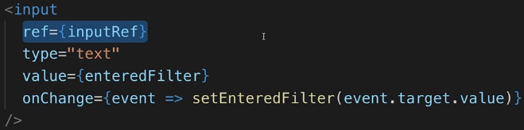  
* Now we established a connection between this input here and the inputRef variable.  
**.current.value**  
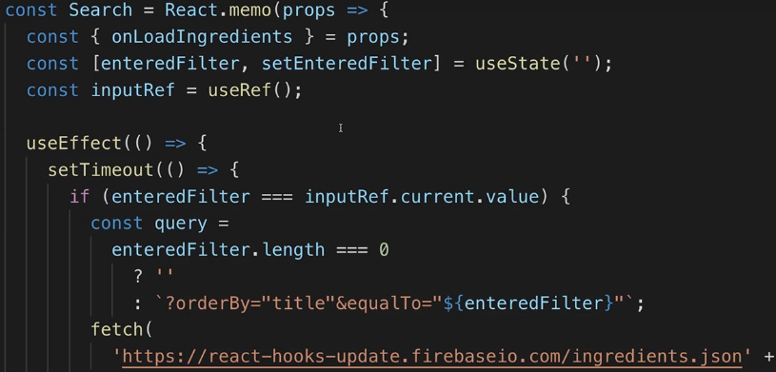  
* One important note here - the inputRef is now also the dependency of our useEffect() because we’re using inputRef in the effect.  
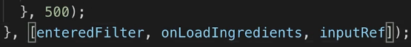  
* We’ll have a problem though - right now we’re not doing this in a perfect way - we’re setting the timer but **keep in mind that we set a new timer whenever the effect runs and the effect still runs in the end whenever our input changes**, **so we’re setting a bunch of timers which are all managed independently**. That’s not really what we want here.

**Cleaning Up with useEffect()**  
* Instead of setting a timer for every effect - therefore having multiple timers for every keystroke - we want to make sure that we always clear the previous timer because it doesn’t matter to us anymore, if there’s a new keystroke, the old timer can be dismissed. We alwayas just want to measure a change from the latest keystroke to after the pause  
* So we want to clean up this timer.  
=> The good thing is setTimeout() in the end gives you a reference - a pointer at the timer - which we can store in a constant. This is the currently active timer.  
* useEffect() takes a function and this function can actually return something - after this timer - at the end of this function, we can return something and when you return something, it always has to be a function, the **Clean Up Function in useEffect()**.  
=> **This function will run right before this same useEffect() function will run the next time**. So not after this function we pass is done, but before the next time it will run.  
  
* **So on the first render the Clean Up Function doesn’t execute**.  
=> But then, on the 1st keystroke we clean up the old effect and run a new one. On the 2nd keystroke, we clean up that previous effect and run a new one.  
**clearTimeout()**  
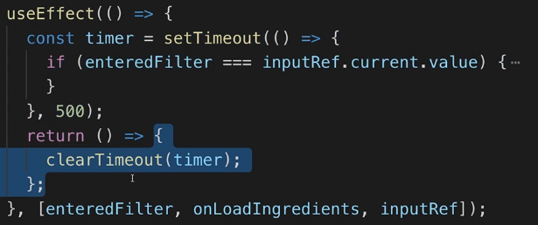  
* This cleans up the old timer before it sets a new one. This **ensures that we always only have 1 ongoing timer which is of course better because we don’t have all these redundant timers in memory**.  
* You might need the clean up in situations like this but also for example if you’re setting up some Subscription to a Web Service or anything like that. Anything which might emit values regularly, you want to cleanup your old subscription for example, if you’re setting a new one with useEffect(). And here it’s the same with the timer so that we don’t have all these redundant timers in our memory which ultimately will take up a lot of memory and make our app slower.

**Deleting Ingredients**  
* Right now we’re deleting the ingredients only locally, not in Firebase.  
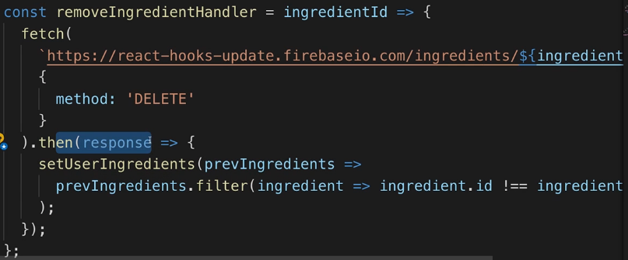 **${ingredientId}.json`**  
* We don’t really care about the response but we only want to update the ingredients in the UI once the response is there.  
**Loading Error & State Batching**  
* **Showing a loader or displaying an error modal are the things we’re going to do next**.  
* Let’s how a Loading Spinner when we’re waiting for an HTTP Request to complete.  
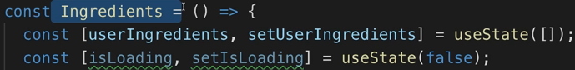

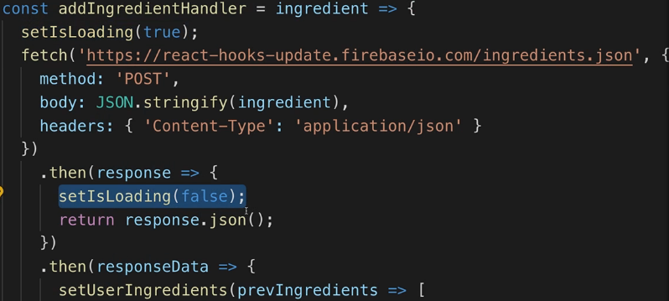  
* I’m going to display it in the IngredientForm.js.  
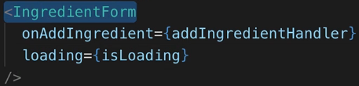  
* In IngredientForm.js:  
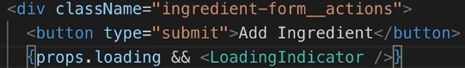  
* Let’s do the same for removing.  
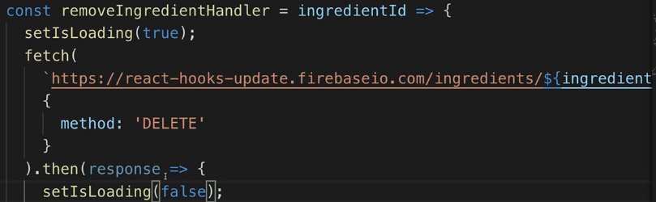  
* **We could do something similar when loading initially, we’ll do that later**.  
* Let’s now handle errors.  
* If we use .jon instead of .json, we force a technical error.  
* With FETCH - since it **returns a Promise**, we can handle errors by adding   
**CATCH**  
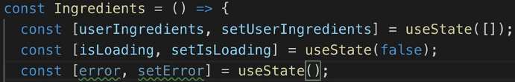

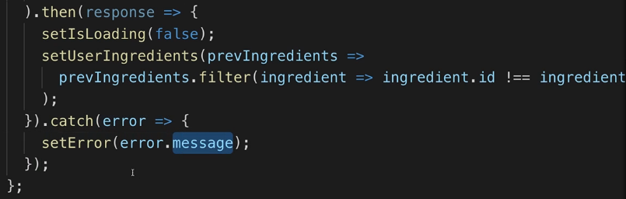

* You can put anything in the setError().  
  
* The ErrorModal:  
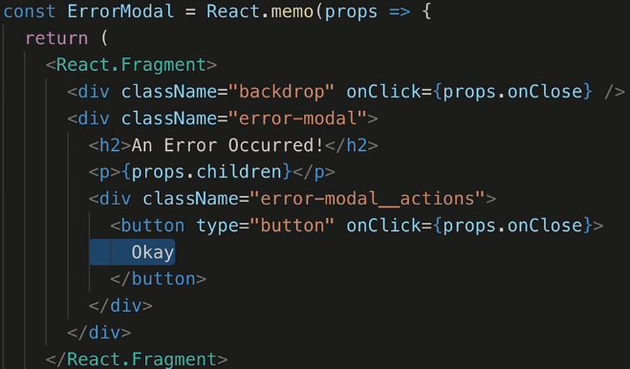  
* When we get an error, the loading should also disappear.  
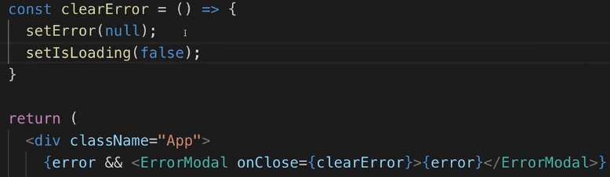  
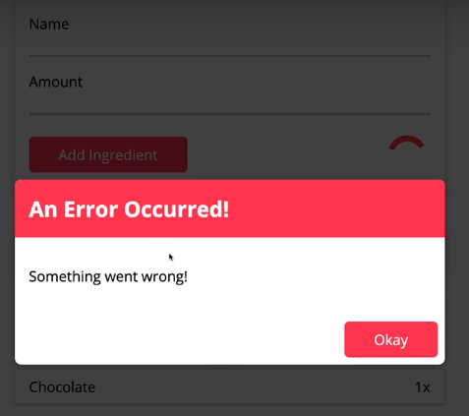 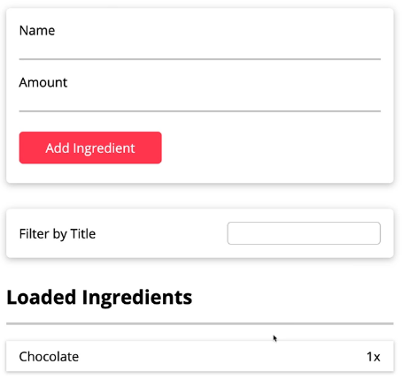  
* **React also Batches state updates**, I’m naming it setState because **whenever you call a set-whatever function from useState(), this will of course trigger a state update** and there React has a mechanism for **Bashing multiple updates together to avoid unnecessary render cycles**.  
* When you set your new state, no matter which approach you use, React Batches the state updates.  
=> **That also means that right in the next line after calling set useState(), you can’t immediatelly use the new state** because React won’t go ahead and update the state and skip all the other code - instead, **it will execute all the other code in the same function and Batch all the state updates you schedules there together**.  
* **So all state updates from 1 and the same SYNCHRONOUS event handler - that’s important - are batched together**.  
* It means that here in clearError() for example I have setError and setIsLoading - this is in the same function, these 2 steps are executed SYNCHRONOUSLY after each other, so even if that were in a THEN block, if they are both in the same THEN block, **then these 2 always run right after each other and then React batches these 2 state updates together**, so this will not mean that setError() causes a re-render cycle and setIsLoading causes another one - NO, **we’ll only have 1 render cycle here** which reflects both state updates.

* **You might want to set the loading to false right there when you get the error**:  
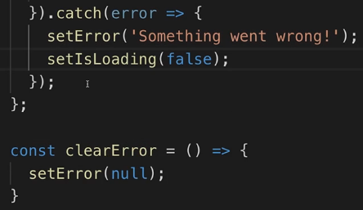  
=> **Then the spinning icon also disappears right when the modal opens**.   
* In that case, the setError and setIsLoading will again be batched together so it’s only 1 render cycle which already has both state updates taken into account.  
* So that’s how React Batches state updates and how you can handle error, with a separate state of course you store errors and then react to them appropriately.

**More on State Batching & State Updates**  
<https://www.udemy.com/react-the-complete-guide-incl-redux/learn/lecture/15701624#announcements>

More on State Batching & State Updates

React batches state updates - see: <https://github.com/facebook/react/issues/10231#issuecomment-316644950>

That simply means that calling

1. setName('Max');
2. setAge(30);

in the same synchronous (!) execution cycle (e.g. in the same function) will **NOT trigger two component re-render cycles**.

Instead, the component will **only re-render once** and both state updates will be **applied simultaneously**.

Not directly related, but also sometimes misunderstood, is when the new state value is available.

Consider this code:

1. console.log(name); // prints name state, e.g. 'Manu'
2. setName('Max');
3. console.log(name); // ??? what gets printed? 'Max'?

You could think that accessing the name state after setName('Max'); should yield the new value (e.g. 'Max') but this is **NOT the case**. Keep in mind, that the **new state value is only available in the next component render cycle** (which gets scheduled by calling setName()).

**Both concepts (batching and when new state is available) behave in the same way for both functional components with hooks as well as class-based components with this.setState()!**

**Understanding useReducer()**  
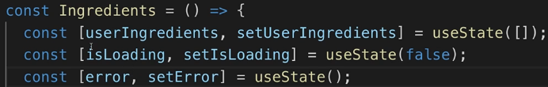  
* In a scenario like this we have 3 different states we’re managing and they’re kind of related. They’re all related to us interacting with an HTTP request.  
* Our userIngredients change whenever we send the request because we’ve reloaded data or we delete the data or we added data.  
* And we’re waiting for this request to be done right before we change ingredients - isLoading, or we might also have an error.  
* So these 3 states are closely related.  
* We’re managing them kind of independently but also we sometimes update 2 at the same time - like if we get an error, we setError() and setIsLoading() right after each other. Thanks to React’s Batching mechanism it’s not a problem.  
* But still it might be a bit annoying to manage these stated independently - and that would get worse if one of the states would depend on another state which arguably kind of is the case already - when we set our ingredients because we added a new one, we’re depending on our old ingredients, it’s not really a different state, we’re not depending on loading or error but it’s the older snapshot of the same state.  
=> In such cases where you depend on the older state or you need to update new state based on maybe also some other new state of another state object, then there is a better way than using useState.  
**useReducer** => **you can call this instead of useState()**=> **Reducers are functions that take some input and return an output in the end and useReducer() uses that to give you a clearly defined way of defining state changes and state updates and it will also then manage that state for you**.  
  
* You typically define the Reducer outside of your component so that this function isn’t recreated whenever the component re-renders because the Reducer function often is decoupled from what’s happening inside your component actually.  
=> This in the end stores a function, this function will automatically get 2 arguments passed in by React:  
**1) state**  
**2) action => important for updating the state**=> Action is an object which could have a type and then we can use a switch statement to define different cases for different code you want to execute for different types of actions we’re getting.   
* You can name the types whatever you want.  
* **You typically also should have a default case**.  
* **The Reducer will return different things for different cases**.  
* For SET, I want to override my current ingredients with a new list, a new array of ingredients and that should be part of the action object we’re getting. So there **I expect to get an ingredient property which should be an array of ingredients which will replace the old state**.

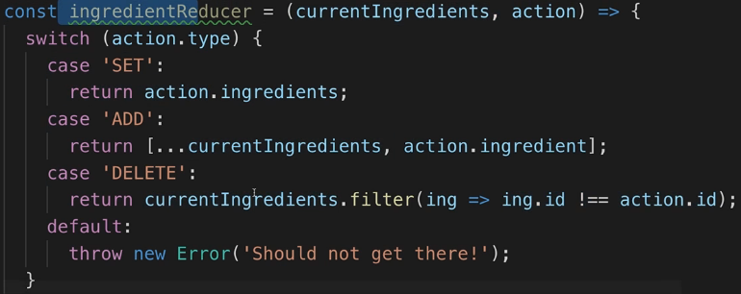  
* That alone doesn’t do much, we need to use it/utilize it by calling useReducer().  
=> It takes our reducer function and an optional **2nd argument which is the starting state** and in our case that’s an empty array.  
useReducer() just like useState() returns something - it also returns **an array** but now not with state and set state but with **state** and **dispatch function** (we’re setting stuff in the Reducer). It’s still a function we can call and you can name this whatever you want. It’s a function which we’ll call to dispatch these actions later.  
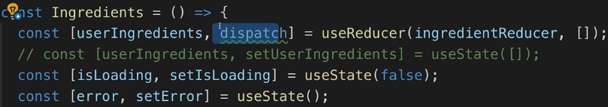  
  
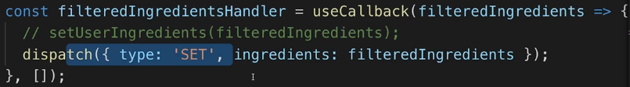

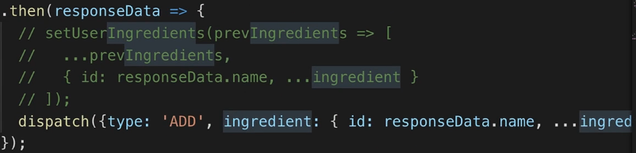

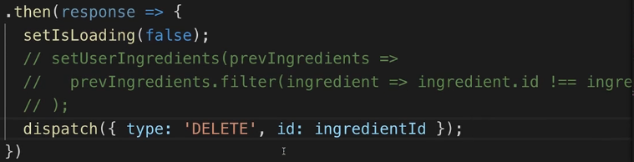

**Using useReducer() for the Http State**  
* So I added useReducer() instead of useState(), not because we replaced so many state things with it - actually we only replaced that 1 userIngredient state but because we have multiple ways of changing that state and some of these ways depend on the previous state.  
* And while the previous approach of course also worked fine, **using a Reducer often is clearer because you have all your updating logic in 1 place, in the Reducer and then you just dispatch these actions**. **Which is a very clear and easy to understand flow for how you manage your data**.

* **So whenever you have a bit more complex state and that might also depend on previous state, then you should strongly consider using a Reducer to have a cleaner logic to have all in 1 place**.  
* **Another scenario where useReducer() could make sense is if you have multiple connected states** like here: isLoading and error - they’re both related to us sending HTTP Requests and while we manage them independently, they’re kind of related.  
* Often a Reducer makes your code easier to reason about, easier to understand.  
* **Always put Reducers outside of your component if you can to avoid unnecessary recreations**.  
* Here we have 3 different cases that make sense, 3 - sending the request, when the response is there and when we get an error.  
* If we see the “Should not be reached!”, then we dispatched some action we’re not handling and then we should either fix a typo or add a case for that action.  
* It’s important to understand that in the Reducer we’ll not send the request itself, we’re doing that down there in addIngredientHandler. Here I just want to manage the state that is related to that request being sent that influences our UI.  
=> So the state there is basically whether we show a Loading Spinner or whether we show na Error. That’s essentially the state I want to manage related to that request.  
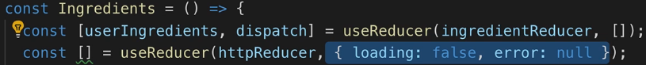  
* Here I’m using an object - we could also use a string, but here I want to have multiple connected fields and therefore I have an object to connect them.  
* **A common pattern is that you set the property you want to set but before you do that, you simply take your existing state and use the spread operator to pull all key value pairs out of it**, merge it with this new object which will be returned as your new state, so that you don’t lose anything from the old state and whatever you set after that, will overwrite any properties of the same name that were pulled out of the old state.  
* For the ‘ERROR’ I’m not using the spread operator because I’m setting both properties.  
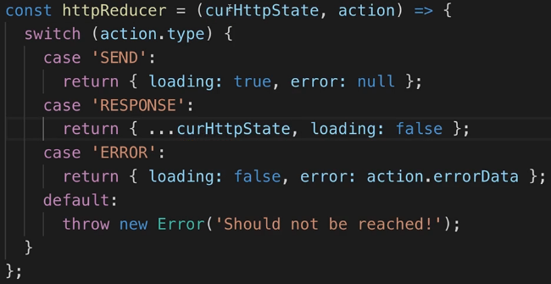  
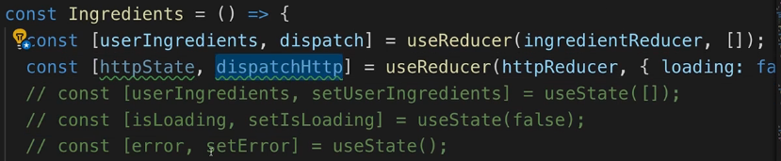  
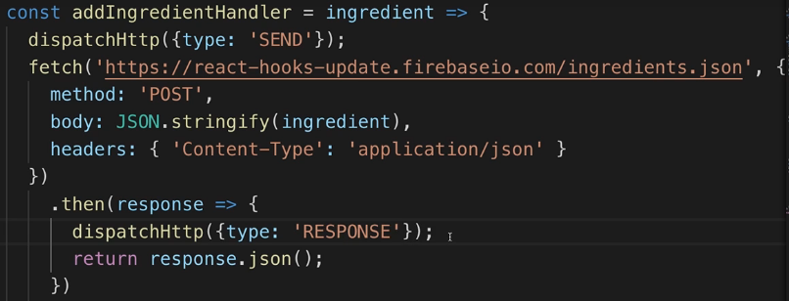

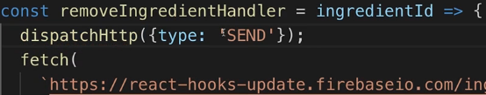

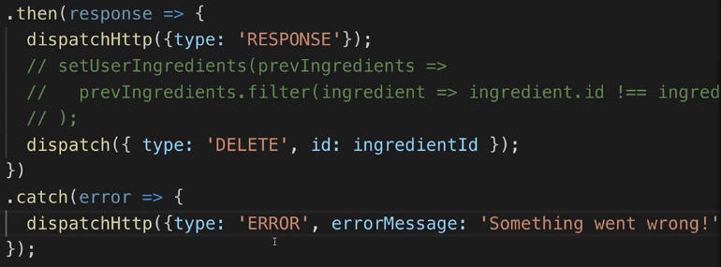  
* Let’s add a new case to the http Reducer.  
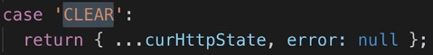  
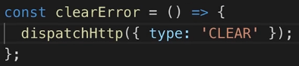  
  
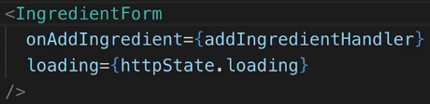  
* So we’re using 2 reducers.  
* Http Reducer - here we’re doing it because we have multiple connected pieces of state which we now can manage in 1 place and still make sure that we always get the old state, that we update everything correctly and that again we take some logic out of our component here and move it into the reducer functions so that we have a cleaner code where we have a clearly defined flow of data and of where we change our data.  
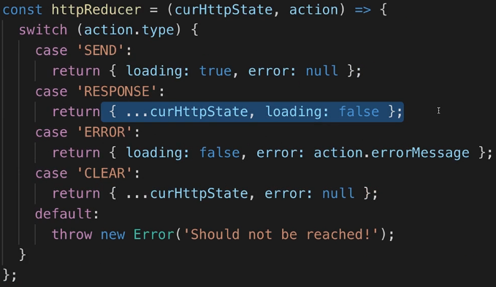  
* **Now we’re managing all our state with useReducer()** **which is an alternative to useState(), if you got more complex state that relies on the old state or if multiple state values work together, and you want to manage them all in 1 place and update them correctly**.

**Working with useContext()**  
* Let’s look at how we can use the Context API which is also an exciting feature about React, together with Functional components and Hooks.  
* For that we have our Auth.js file:  
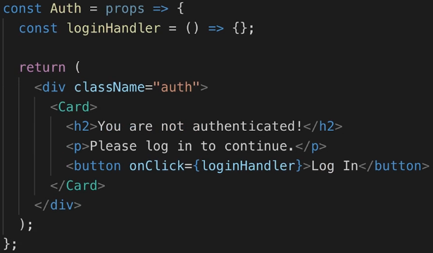  
* In App.js I want to show that if you’re not logged in yet, and alternatively show my Ingredients.js if we are logged in.  
* Now of course for that we can manage all of the logic in App.js and use an IF statement to render different content but in a more complex app of course, you might be interested in whether the user is authenticated or not, in a couple of components, maybe deeply nested into other components and therefore passing data about the authentication status **via props might not be what you want to do because you build very long chains of props which you have to pass around**.  
=> **That’s where Context can help us**.  
* **I like to store my context in a `context` folder**.  
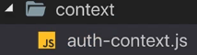  
**createContext() => we can initialize it with a value.**  
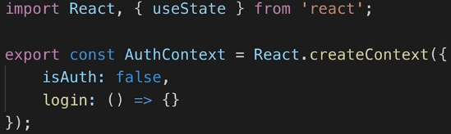  
* The login function is just an empty function but which I still add here to get better autocompletion.  
* We’re overwrite the login function with the concrete value soon.  
* I’m exporting the Context object but I’m also using it in the same file to create a component.  
**<AuthContext.Provider>**  
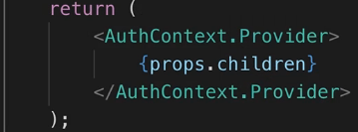  
* I’m going to use useState() because it’s a really simple state.  
* The Provider gets a value which will automatically be distributed to everyone listening if it changes, which describes our Context. I will immediatelly overwrite it with a new object.  
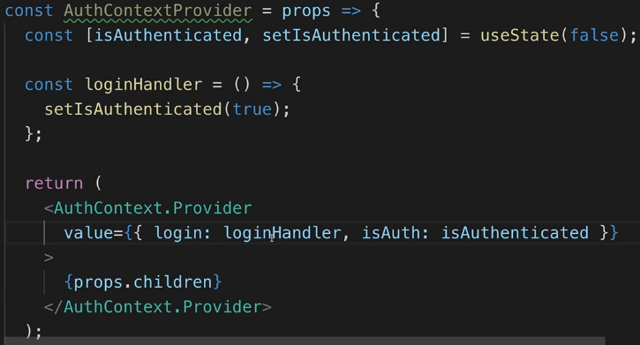  


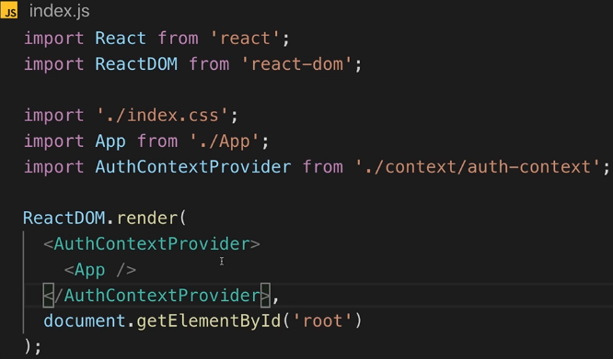  
=> **Now our entire app is able to receive the context, you can listen to the Context from anywhere in the app**.  
* That’s the thing which could be problematic with Functional props - we can of course import our AuthContext - so not the Provider component but the Context object itself.  
**<AuthContext.Consumer>** => we wrap it with this to set up this render function in the end in there.  
  
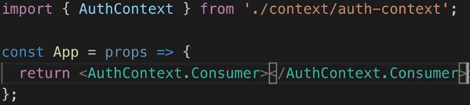  
=> This would be how you can use Context in Functional components.  
=> This means that if you need data from Context anywhere else but in your JSX tree, you have no way of getting it, you would need to transform this into a Class based component so that you can add the **static contextType** thing which you might remember from earlier in the course.  
=> Thankfully, there’s a Hook to fix this.  
**useContext()** => you pass in the Context you want to listen to and you get a handler to that Context which is then stored in this constant, you can name it whatever you want.  
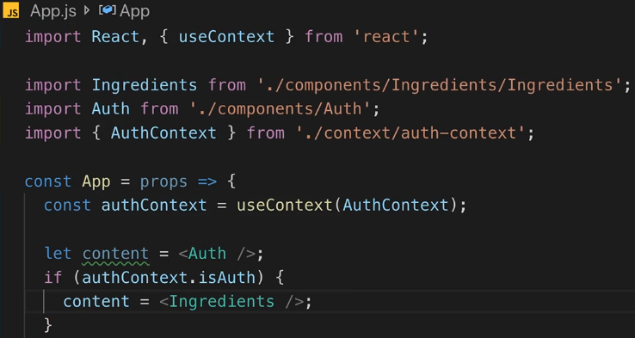  
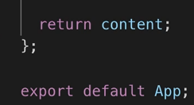  
=> **This will be rebuilt whenever the Context changes whenever the value in there changes**.  
=> And now we can check the isAuth.  
* Now we just need to make sure that clicking on the “Log In” button also reaches the loginHandler() funciton in auth-context.js. The pointer to this function is stored in the `login` in the Context.  
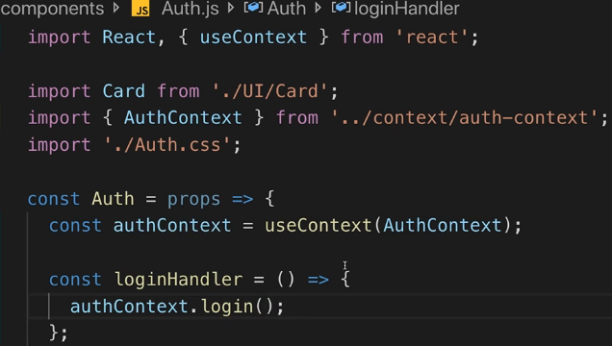  
* Now if we click the button, we’re logged in, we see the Ingredients.

**Performance Optimizations with useMemo()**  
* Let’s see how we can optimize our project, how we can   
**avoid unnecessary re-render cycles** because that’s of course something we might also be interested in doing to ensure that we have an app that performs well.  
* In Ingredients.js we’re managing a bunch of logic - we have 2 reducers in there, we’re changing the loading state for example and we update the UI.  
* One thing I can already see there is that for example we’re passing the addIngredientHandler to the IngredientForm and **since addIngredientHandler in the end is just a function defined inside of this Fuctional component, whenever this component rebuilds/re-renders, this function will also be recreated**.  
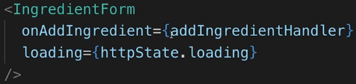  
* **A side note - useReducer() will not be recreated - it’s of course called again but React detects that this useReducer() is already for this component and uses that already initialized value, so that’s not a problem**.

* Even though I’m using React.memo(), this function inside of the component will rebuild, we can confirm that by adding a console log.  
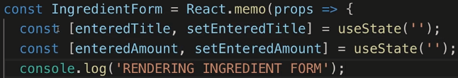  
=> **Theoreticaly, this should only be rendered whenever we type in there because these are the only things that change the form - and of course when we initially loaded**.  
* If I hit “Add Ingredient”, you see it’s re-rendered a bunch and that makes sense because it’s re-rendered when we change the loading state but it’s also re-rendered once the data is there and we’re outputting the data down there and this is not what we would want, there’s no reason to render this form if we’re just outputting some data down there.  
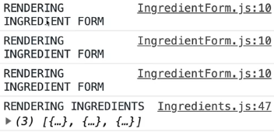  
* So that should be 1 render cycle too much we have, 2 make sense gbecause we switch loading from false to true and then back from true to false once we’re done and the loading spinner is in the form.  
* But the 3rd render makes no sense.  
=> **We can get rid of that by wrapping addIngredientHandler with useCallback() which we already saw before and then you add [] to define the dependencies if this function**.  
=> The dependency here is the dispatchHttp() which you don’t need to specify because just like the updating function from useState(), this is guaranteed by React to not change between render cycles, so you could add it but you don’t have to. `ingredient` is a local argument were getting in the function, not an external one.  
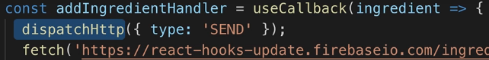

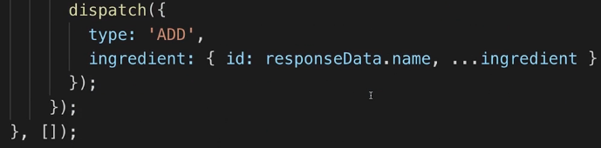  
=> Therefore overall there is nothing in here on which it is dependent so this function actually should never be rebuilt, it’s always the same function, it has no external dependencies other than dispatchHttp which is managed by React such that it won’t change, so it’s not really a dependency.  
* Now if we try it, we only see 2 render cycles:  
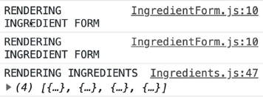  
  
* Now this addIngredientHandler function is not rebuilt, we’re passing this function into IngredientForm but since it doesn’t change between render cycles, React.memo() detects that the new function we’re getting when the parent component rebuilds is the old function and therefore doesn’t rebuild this component.  
* So now we’re taking advantage of **React.memo()** here.  
* The same for IngredientList - when we change the ingredients, this should rebuild, but it will now also rebuild all the time because we pass in the removeIngredientHandler and that’s also not wrapped by useCallback().  
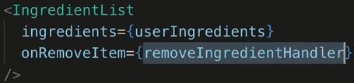  
* The dependencies of IngredientList are onRemoveItem.  
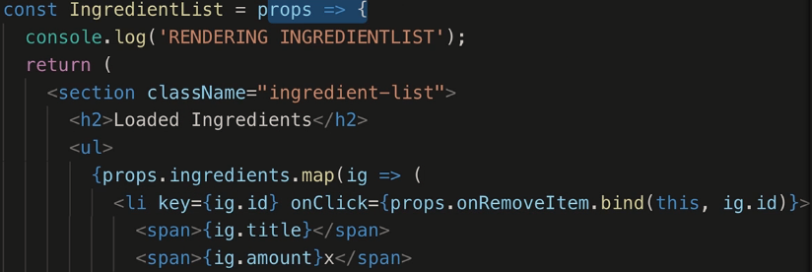  
* Note that I’m not using React.memo() in here.  
=> **So the following change will not have a result alone**.  


  
* Dependencies are again dispatchHttp which we don’t have to specify.  
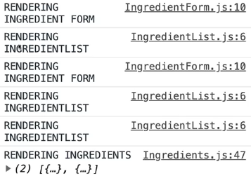  
=> **Now we can use React.memo() to make it work**.  
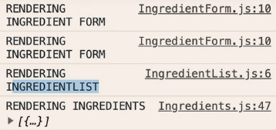  
* **There’s nothing wrong with doing this and actually this is the approach you’ll typically use**.  
* But I want to show you an alternative - using a Hook.

**useCallback()** => **was a Hook to save a function that doesn’t change, so that no new function is generated**. **useMemo()** => **a Hook where you can save a value which is saved so that the value isn’t recreated**.  
=> **That’s another way of memorizing a component**.  
* That would be the IngredientList here.  
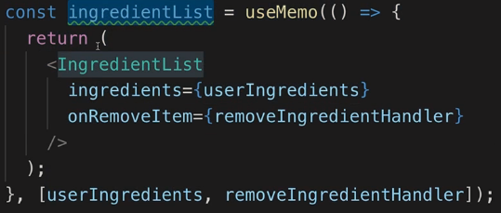  
=> The function in useMemo() returns the value you want to memorize - IngredientList here.  
=> It also needs a 2nd argument which is also a list of dependencies you have, tells React when to recreate the value we want to memorize.  
* Really only userIngredients will cause it to re-run because removeIngredientHandler should not change.  
* We can output it like this:  
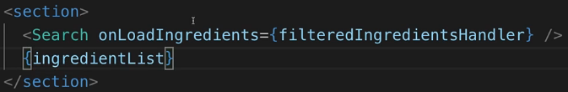  
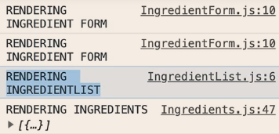  
* **If we’re talking about storing components, you typically want to use React.memo() instead of useMemo(). But keep in mind that with useMemo(), you can store any data which you don’t want to recreate on every re-render cycle of this component**.  
=> **So if you have some operation which calculates a more complex value, than you want to consider wrapping it with the useMemo() so that it’s not recalculated whenever the component re-renders but really only when you’d need to recalculate it**.  
* Last optimization if for the clearError().  
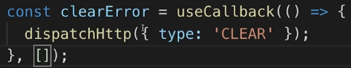  
* This component already uses React.memo().  
* So these are some optimizations you can apply and you should think about.  
* It’s not the end of the world if you forget one because re-rendering sounds like a super intensive work, if it’s a small component, an easy update, might be super fast to re-render and **re-render always means re-rendered in the virutal DOM**.  
=> It doesn’t mean that whatever change is automatically written to the real DOM.  
=> **But even that virtual DOM re-rendering can be avoided with useCallback(), useMemo() and React.memo()**.  
* **But if you have very trivial components, it might even be worth not adding React.memo so you shouldn’t wrap every component with React.memo() or useMemo() because React then always needs to check whether props changed and if it’s a super small component, re-rendering it might just be faster than performing that check**.  
* So it’s always something you have to evaluate and think about.  
* For example for the ErrorModal we could probably get away with always re-rendering that and not using React.memo().  
* So there are things you just have to play around with, test and also check fast your application is, to get a feeling for this - where it makes sense and where it doesn’t make sense.

**Getting Started with Custom Hooks**  
* One very cool feature is missing - **Custom Hooks**.  
=> You can build your own Hooks.  
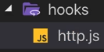  
* Because I have that HTTP functionality in Ingredients.js for example, where I send HTTP Requests, I do this multiple times and the pattern is always the same.  
=> dispatch ‘SEND’ at the beginning, dispatch ‘RESPONSE’ once the response is there, dispatch ‘ERROR’ if we have an error.  
* So we have logic that we want to share across components but - and that’s important - logic which also influences the state of the components where we want to use that logic.  
=> So we can’t use a normal function - because of course we could build our normal send request function which simply has all that send request logic in there but from within that normal function, **we couldn’t dispatch events which then change the state in a component that called the function**.  
=> **That’s something only Hooks can do**.  
* **Your own Hooks should always be named useSomething**.  
=> **It’s a normal function, just treated in a special way by React**.  
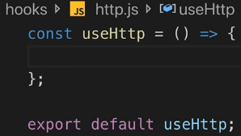  
=> **The cool thing is you can now use STATEFUL features, you can use useState(), useEffect(), useReducer(), you can use any Hook in there and any component that uses your own Hook will then run this Hook as if you had the code written directly in your component**.

* **So it’s not like you have 1 function shared by multiple components and then they run the same code with the same data - NO, each Function component gets its own snapshot of this Hook so to say. The STATEFUL logic will be different for each component where you use that Hook, so that you can share the logic, not the data, that’s the idea behind Hooks**.  
* I’m going to **cut the httpReducer and put it in http.js but OUTSIDE the Hook** because **this doesn’t need to run with every render cycle** and **your Hook will re-run with every re-render cycle**.   
* Your Hook will get called whenever the component where you’re using your Hook gets re-rendered and then you can use techniques in your Hook of course to make sure that nothing happens to the state or that something does happen - depending on what you want, but in general it will get re-executed. **I don’t want to recreate the reducer all the time, so I’ll move that out of there**.

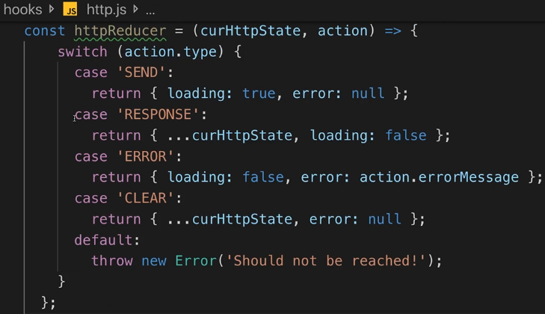  
* **Let’s also remove the useReducer call**.  
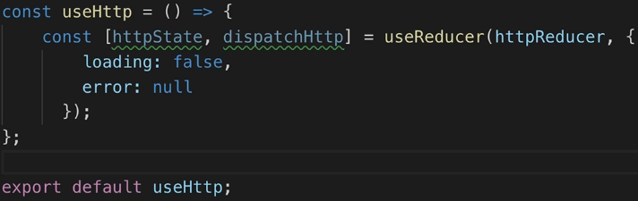  
* **Now let’s cut the whole FETCH block and put it in the useHttp**.  
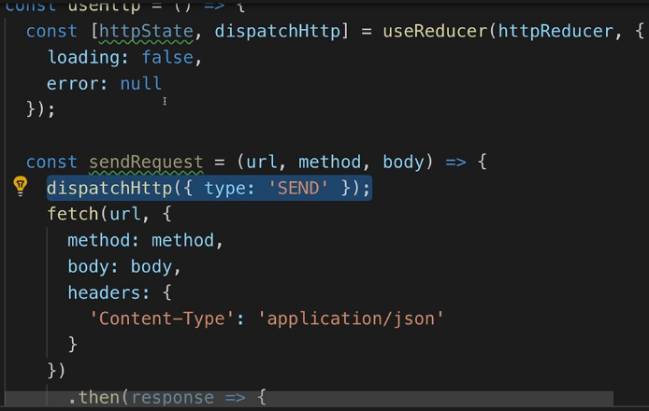  
=> That would now execute the HTTP Request whenever the component that uses useHttp re-runs, that’s certainly not what we want here.  
=> Let’s create a sendRequest() function and put it in there, so it will send the HTTP Request only when the sendRequest() function is called.  
* The url, method and body should be received from outside, to give us some flexibility.  
* It won’t hurt if we put the Content-Type header there always.  
* **We’re using dispatchHttp, that’s the STATEFULNESS I was talking about**.  
=> We’re interacting with our Reducer here because this custom Hook will in the end be used in a component which then will automatically get all that state - where this state will be connected to by React automatically.  
* What we do with the response - in this case deleting the ingredient, that doesn’t belong into this Hook, that’s something the component that uses our Hook needs to do, **the Hook should be just caring about the HTTP Requiest, not about what we do with the response**.  
* But how can we get the response data back to the component that uses this Hook?

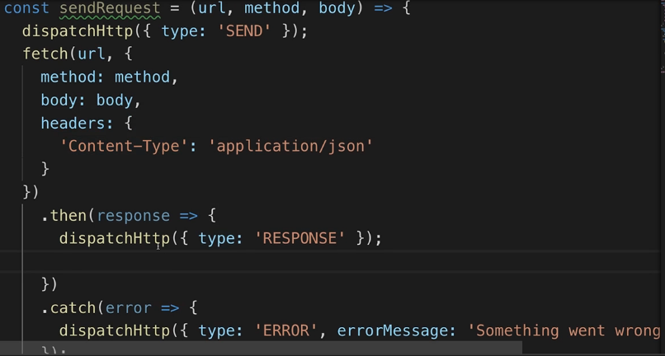  
=> We can add something new to our http state here - let’s start with the initial state.  
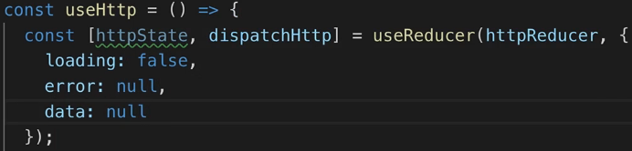  
=> Besides loading and error we can have some data in there which initially is null.  
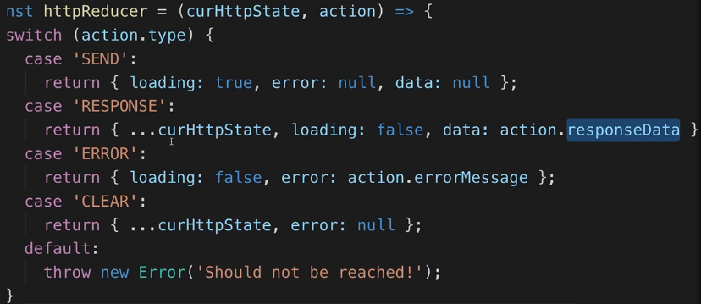  
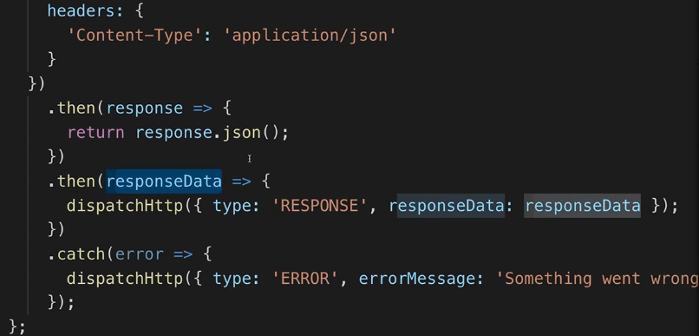  
* Now the important thing is - the data we’re getting for the Request we’re sending, is stored in our state here in httpReducer.  
* **How do we now connect this to our component?**  
=> Just like some of the built-in Hooks, our Hooks can of course return something.

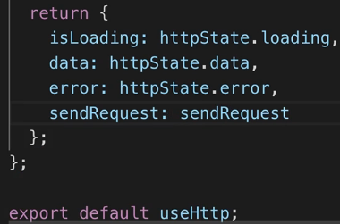  
* **You can return an object, an array, a number, whatever you want**.  
=> It’s coming from this httpState:  
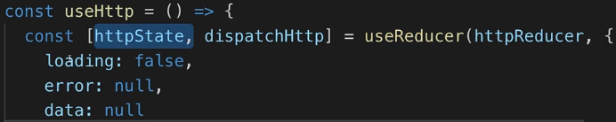  
* Now we can use our Hook.  
* Let’s use it in Ingredients.js.  
  
=> **You have to use it on the root level**.  
* Our useHttp() doesn’t send the request actually, it just sets up the logic for sending a request, it sets up our state and it sets up the sendRequest() function which sends the request.  
=> So we return that function too.  
* **To avoid unnecessary re-renders, let’s use useCallback().**  
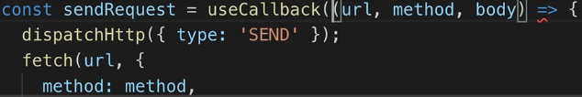  
=> There are no external dependencies.  
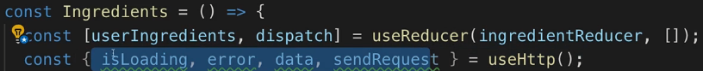  
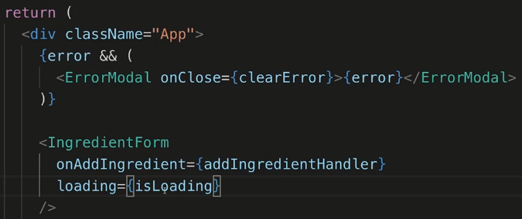  
* **When we’re deleting an ingredient here, I use the sendRequest().**  
* **Now sendRequest() is now a dependency of useCallback(). If we didn’t wrap sendRequest() with useCallback() inside of useHttp(), the sendRequest() would actually change whenever the component where we use useHttp() re-renders, and therefore removeIngredientHandler would change and we would again lose all our optimizations**.  
=> **Since we use useCallback() in our custom Hook, we ensure that sendRequest() never changes and we can safely add it as a dependency, it will not change**.  
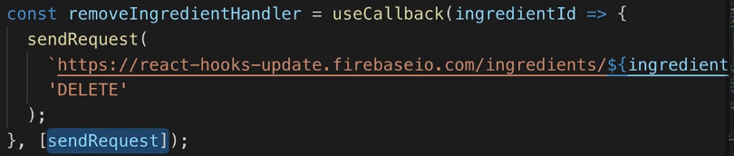  
* So now we’re sending this request when we click to remove an ingredient.  
* Now when we click to delete an ingredient, it’s deleted but we don’t see it in our application because we currently don’t update our ingredients.  
=> **We have our Hook for managing HTTP Requests but for updating our data, we have no solution yet**.

**Sharing Data Between Custom Hooks & Components**  
* How can we update our ingredients in Ingredients.js when our delete request is done?  
=> **We can use useEffect() => runs after every render cycle.**  
=> sendRequest in useHttp() sends a request and in that request in the end we dispatch response if we succeed.  
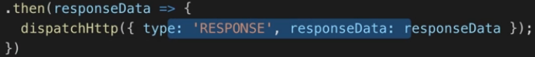  
=> **This updates the state and therefore it will retrigger that component that uses our Hook to rebuild itself**.   
=> **So when sendRequest() is done, the Ingredient.js will rebuild**.  
* If we used the same Hook in a different component, that other component would not rebuild because the logic is copied for every component, they’re not sharing the same data.  
* So if A sends a request, that doesn’t mean that B also sends a request.  
=> In Ingredients.js we can listen to the data being changed, because we know once there response from deleting is there, - for DELETE request we get no data but still we’ll set a new value in the data and that alone should suffice and the Ingredients.js rebuild.  
=> We need an ID, a solution could be that we add a feature to our Hook.  
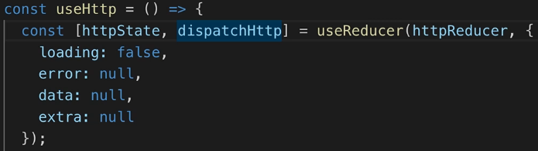  
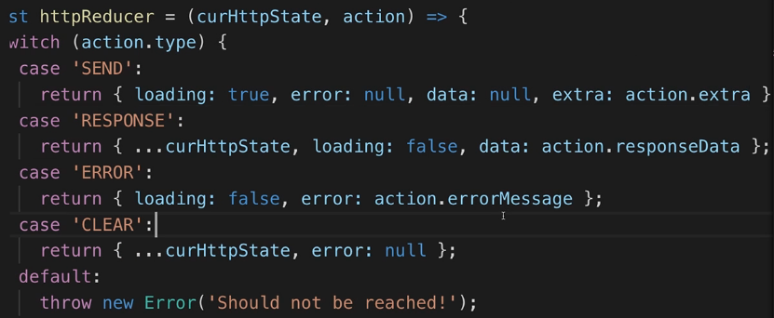  
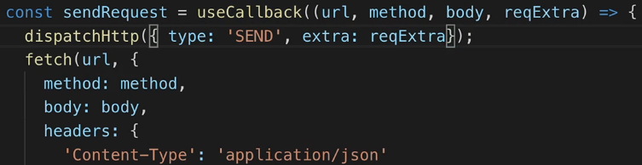  
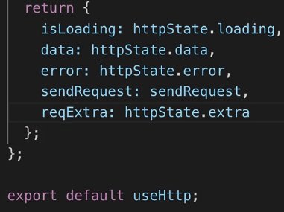  
* Ingredients.js.  
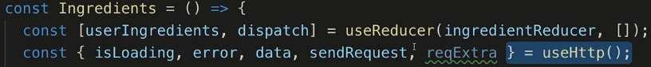  
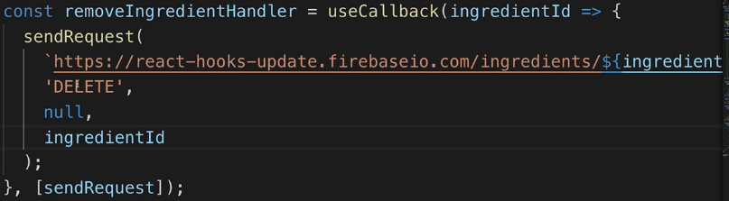  
* Once the request is done, the data will be emitted and therefore this useEffect() will run:  
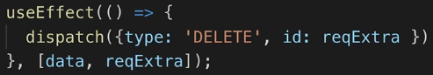  
=> Which dispatches the DELETE action which adjusts our ingredients:  
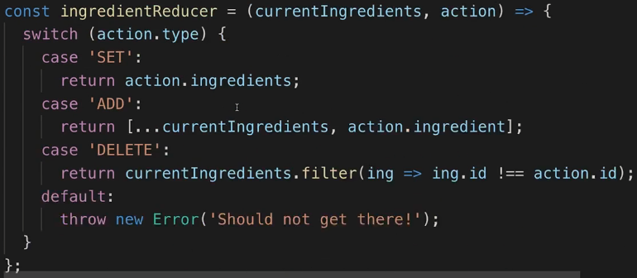  
* **Let me step in here for a second and make it really clear that it can be strange to think about HTTP Requests like this at first - that we’re sending them somewhere and we’re handling the response somewhere else, in useEffect() here. Nonetheless, this really embraces the concept of Hooks after all, and while it can be strange to look at HTTP Requests like this initially, it actually makes handling it much more elegant in the long run I believe because you can clearly see in your code where you’re handling result of your Request, where you’re changing your data and where you’re just dispatching that Request, where you’re sending it off**.  
* **I want to emphasize this - an alternative would have been that the sendRequest() function we’re returning in our useHttp() Hook, that this function for example returns the normal Promise that FETCH API always gives us, so that in the places where we called sendRequest(), we can add a then() and catch() block and then simply still do our login in those blocks, instead of using useEffect().**  
* This approach here of splitting the sending of the request and the handling of the response can be more confusing initially because now **you have to care about getting things like that request extra from where you send the request to where you handle the response - which is our useEffect() here**.  
**\* In the long run, it’s cleaner code where you split your responsibilities** and where you just have to switch the way you think about it and then you will have no problem with that approach.  
* Just be aware that if you don’t like this approach, you could return a promise in useHttp() Hook instead of sendRequest() there and then simply chain all your response-handling logic after sendRequest() in this Ingredients.js component.  
* **But using this approach here with useEffect() handling the response, simply is the approach where you really embrace Hooks and use them to their fullest potential**.  
* Let’s fix the addIngredientHandler now.  
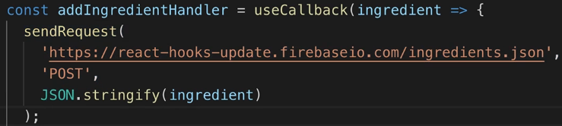  
* Now again we can use useEffect() to react to the data change.  
* And we already dispatch DELETE in our current useEffect() always when the data changes, that’s probably not what we want here.  
=> **In the end, we can find out what should be dispatched**.  
  
* We only use the reqExtra for delete requests.  
* And to make sure this gets cleared for every new request, I’ll set extra: null when we send the request but instead store it on the RESPONSE.  
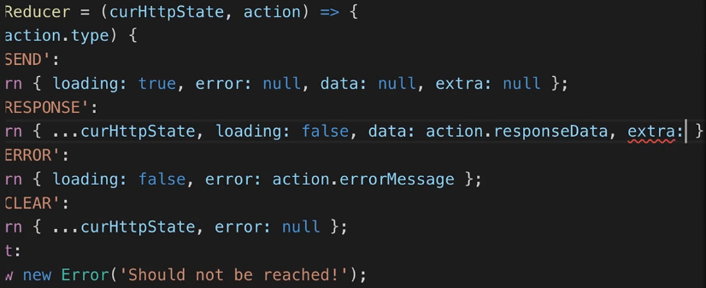  
* And also remove it from the SEND dispatch.  
  
* And use it once the response is there.  
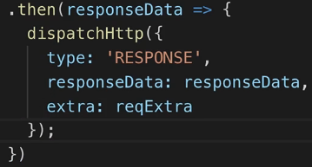

* Now we’re missing the ingredient:  
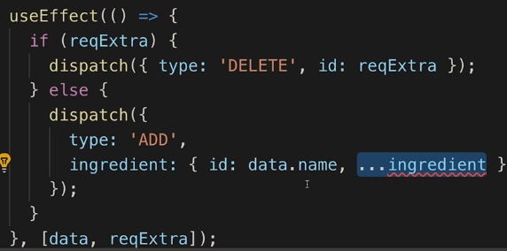  
=> We could send it along as a reqExtra of course but then this IF check wouldn’t work.  
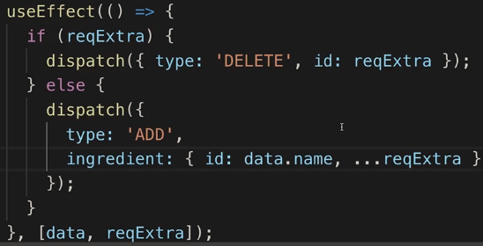  
* In addIngredientHandler let’s forward that ingredient as an extra.  
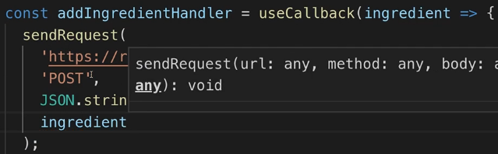  
* **Now we need a way to differentiate the 2 extras**.  
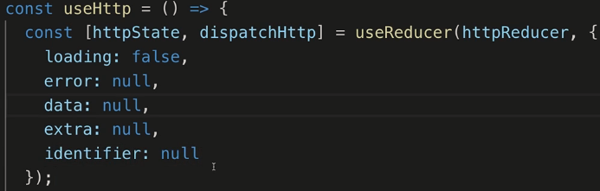  
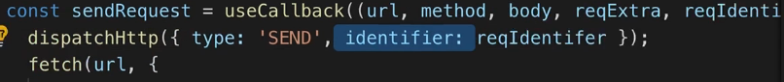  
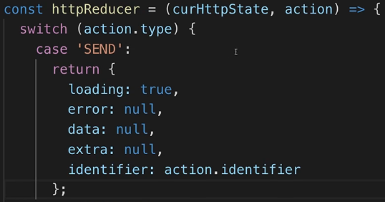  
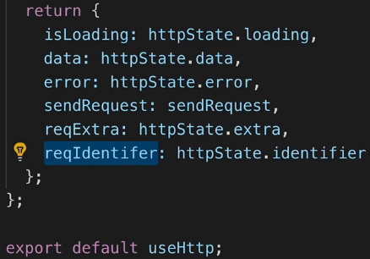

* **So now we can append an identifier to every HTTP request**.  
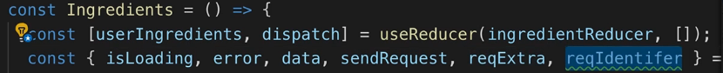  
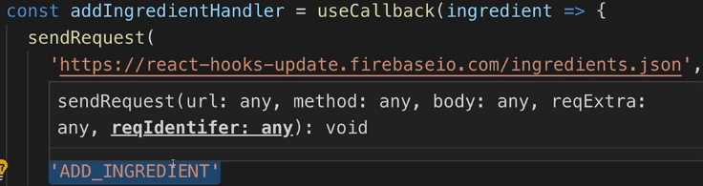  
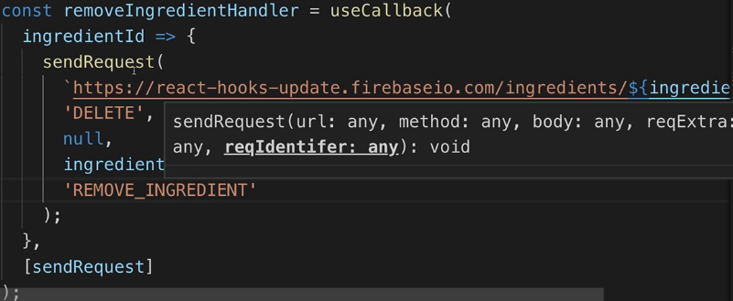  
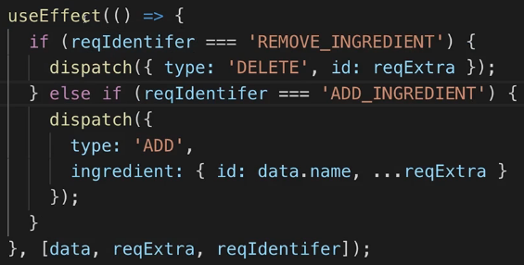  
=> **We have to check for loading because otherwise we call it when we’re not done loading yet and it might be null, the data is set once the response is there**.  
* **And we also want to make sure we have data - or that we don’t have an error, that’s a better check probably**.  
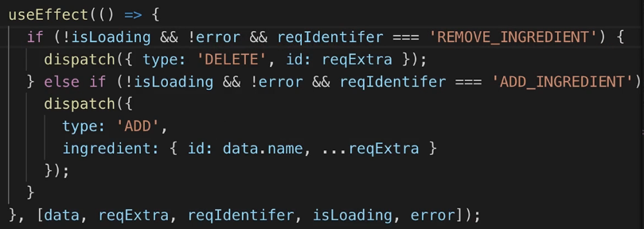  
* Now it all works fine.

**Using the Custom Hook**  
* For addIngredientHandler we’re getting a warning - we’re missing a dependency so let’s add it:  
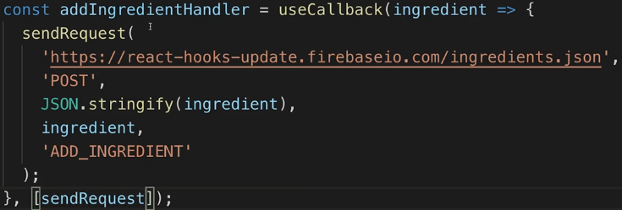

* Now both addIngredientHandler and removeIngredientHandler have sendRequest as a dependency, **thankfully it’s wrapped in useCallback().**  
* Right now we’re not clearing errors.  
=> Let’s do that with the help of our custom Hook here as well.  
* In http.js.  
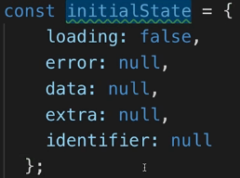  
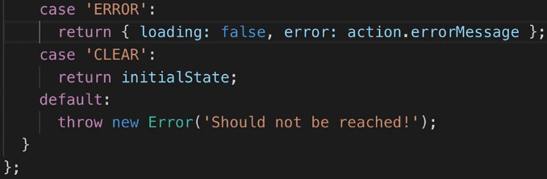  
  
* CLEAR is something we can dispatch but we’re never dispatching it anywhere.  
=> Let’s create a new function inside of useHttp().  
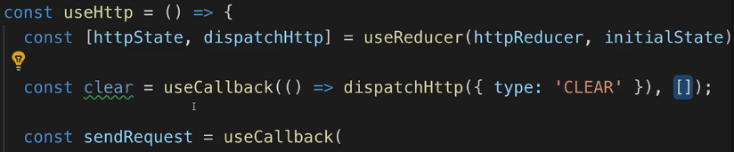  
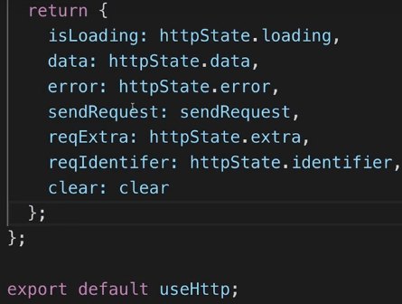  
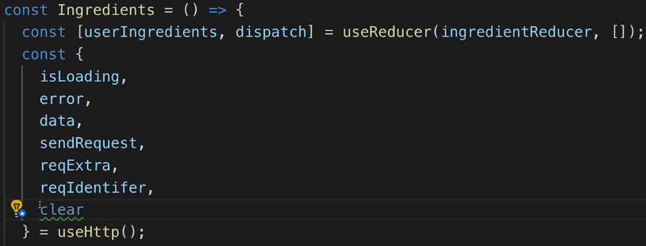

* Now we can call it like this:  
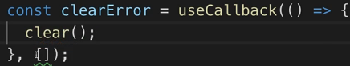  
* Or, we get rid of clearError() and we just point at `clear` - it’s that extracted function we’re getting from our custom Hook which is already wrapped in useCallback():  
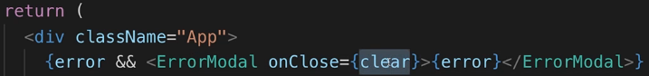  
* Now it all works.  
* Another place we can use our custom Hook is in the Search.js.  
=> There we’re also sending an HTTP Request.  
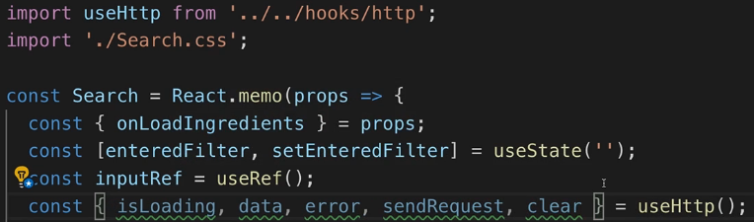  
* In this component we don’t need the identifier because it’s the only request we’re sending.   
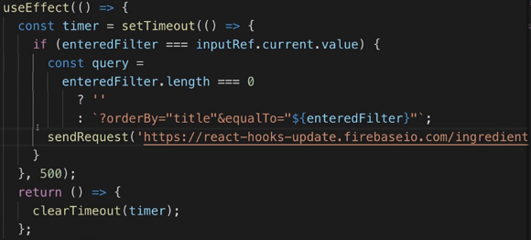  
  
=> I cut the transformation logic out of there and will use it somewhere else:  
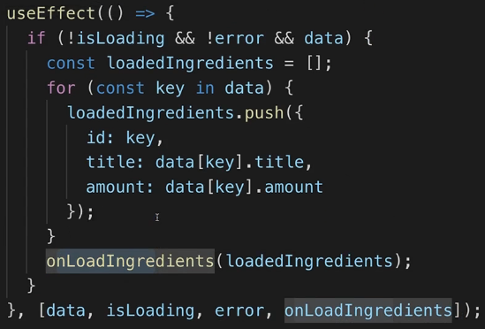

* Let’s now also add error handling here.  
* Let’s also show a little loading indicator between the label and the input - adding the spinner would distort the interface, instead, I’ll just output a text.  
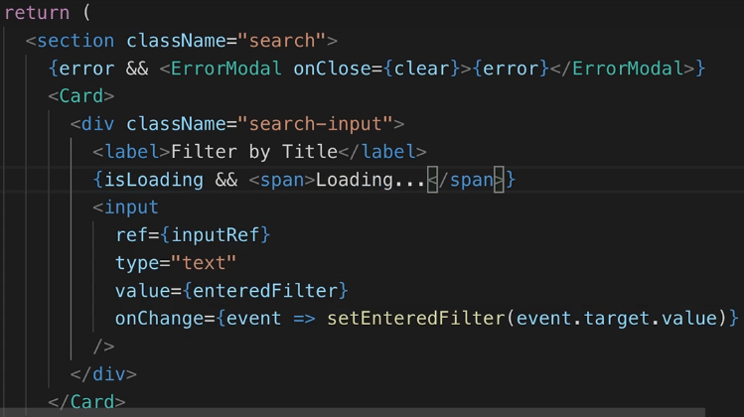  
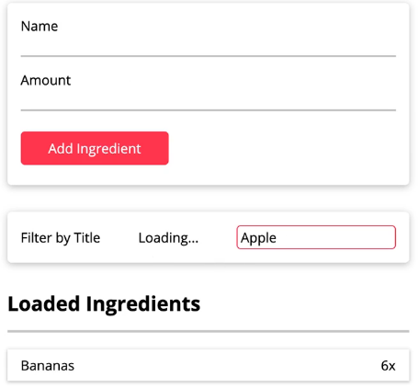

**Wrap Up**  
* I know that especially this Custom Hook thing can be confusing - also because we built a quite complex Custom Hook here, you can definitely have simpler ones than this one but I wanted to show one where you learn a lot.  
* **The idea of Custom Hooks is that you share STATEFUL logic across components, not data**.  
* We share logic that we use in both the Ingredients.js and Search.js.  
* And when we send the request in Ingredient.js, it doesn’t do anything in Search.js.  
**\* It is STATEFUL because in our Custom Hook we’re using useReducer() to manage some state and when we dispatch a new action (SEND for example) here, this actually triggers React to rebuild the component where we used the Hook**.  
* **So we’re not having a regular JavaScript function here but a function where we can do certain things that will lead React to rebuild the component in which we’re using this function, this Hook**.  
* While Custom Hooks can be confusing at first, they can be very powerful because we were able to move all of that HTTP logic out of the Ingredients.js and instead we just send off some Requests using sendRequest(), and we handle responses in useEffect().  
* **That of course is also a pattern you have to get used to**.  
=> Normally you would expect sendRequest() to return a Promise and then use then() or async await to handle this. And you could do this of course.

* You could do something like this instead of using it in useEffect():  
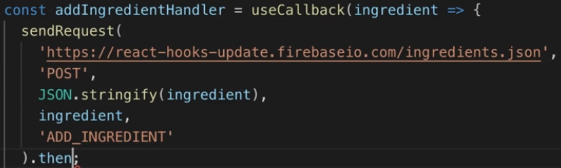  
* **This split into a place where you send it and then useEffect() where you handle it can be especialy confusing at first but it actually embraces Hooks and uses their full potential**.  
**\* I believe it’s a very clean code in the end where we have a clearly defined place where we change some data in our component - and we could have multiple useEffect() calls of course if we have multiple side effects**.  
* **So we have a clearly defined place where we do that and we have another place where we dispatch our actions - where we send our requests**.  
* It’s something that certainly takes time getting used to, it’s not a MUST DO, you could return a Promise and use your regular flow but I think this split is very nice, very clean and most importantly this overall use of a Custom Hook and of Hooks in general allows us to write very clean code with clear responsibilities which can be challenging at first but which ultimately will allow you to write better cleaner and probably also better performing applications.

**Resources**  
Understanding Closures  
<https://developer.mozilla.org/en-US/docs/Web/JavaScript/Closures>  
Reference vs Primitive Types  
<https://academind.com/learn/javascript/reference-vs-primitive-values/>